nation: Assistant Professor
BACHELOR DEGREE
IN
COMPUTER SCIENCE AND ENGINEERING
AND
INFORMATION TECHNOLOGY

SUB. CODE: CS6411& IT6411
SUB. NAME:NETWORKS LAB

MANUAL



MEENAKSHI SUNDARARAJAN ENGINEERING COLLEGE CHENNAI -24

Prepared by
Name: S.Aarthi & R.Gayathri
Designation: Assistant Prof.
Department : CSE & IT

INDEX
S.No. | TITLE | PAGE NO.
1 | IMPLEMENTATION OF STOP AND WAIT PROTOCOL
2 | IMPLEMENTATION OF SLIDING WINDOW PROTOCOL
3 | STUDY OF SOCKET PROGRAMMING
4 | SIMULATION OF ADDRESS RESOLUTION PROTOCOL
5 | SIMULATION OF PING AND TRACEROUTE COMMANDS
6 | IMPLEMENTATION OF UPLOADING AND DOWNLOADING A PAGE
7 | IMPLEMENTATION OF REMOTE PROCEDURE CALL
8 | IMPLEMENTATION OF SUBNETTING
9 | IMPLEMENTATION OF ECHO CLIENT SERVER APPLICATION
10 | IMPLEMENTATION OF CHAT CLIENT SERVER APPLICATION
11 | IMPLEMENTATION OF FILE TRANSFER APPLICATION
12 | IMPLEMENTATION OF DOMAIN NAME SYSTEM
13 | IMPLEMENTATION OF SIMPLE NETWORK MANAGEMENT PROTOCOL
14 | STUDY OF NETWORK SIMULATOR 2
15 | SIMULATION OF TRANSMISSION CONTROL PROTOCOL
16 | SIMULATION OF CONGESTION CONTROL ALGORITHM
17 | PERFORMANCE STUDY OF LINK STATE,FLOODING AND DISTANCE VECTOR ROUTING ALGORITHMS

LIST OF EXPERIMENTS
Sl.No. | Name of Experiment
1.  2.  3.  4.  5.  6.  7  8.  9.  10.  11 | Implementation of stop and wait protocol and sliding window protocol . Study of socket programming and client – server model  Write a code simulating ARP/RARP protocols.  Write a code simulating ping and traceroute commands  Creation of socket for page upload and download.  Write a program to implement remote procedure call.  Implementation of subnetting  Applications using TCP sockets like  i) echo client and echo server  ii) chat  iii)file transfer  Applications using tcp and udp sockets like  i)DNS  ii)SNMP  iii)File transfer  Study of network simulator (ns).and simulation of congestion control algorithms using ns2  Perform a case study about the different routing algorithms to select the network path with its optimum and economical during data transfer  i. Link state routing  ii. Flooding  iii. Distance vector
1.IMPLEMENTATION OF STOP AND WAIT PROTOCOL

AIM
To write a program to implement stop and wait protocol for transmitting data frames.

OBJECTIVE
To understand the working of stop and wait protocol in transmitting data frames.

SOFTWARE REQUIREMENTS
- OS – Windows XP
- Turbocpp Compiler
DESCRIPTION
Stop and Wait protocol known as positive acknowledgement with retransmission is the fundamental technique to provide reliable transfer under unreliable packet delivery system. Stop and Wait is a mechanism of flow control used widely in the Data Link Layer. The working of Stop and Wait protocol is:
(1)After transmitting one packet, the sender waits for an acknowledgment (ACK) from the receiver before transmitting the next one. In this way, the sender can recognize that the previous packet is transmitted successfully. Stop and Wait guarantees reliable transfer between nodes.
(2) The sender keeps a record of each packet it sends. To avoid confusion caused by delayed or duplicated ACKs, stop-n-wait sends each packet with unique sequence numbers and receives that numbers in each ACKs.
(3)Timeout: If the sender does not receive ACK for previous sent packet after a certain period of time, the sender times out and retransmit that packet again. There are two cases when the sender does not receive ACK: One is when the ACK is lost and the other is when the frame itself is not transmitted. To support this feature, the sender keeps timer for each packet.
ALGORITHM
Step 1: Start the program.
Step 2: Generate a random that gives the total number of frames to be transmitted.
Step 3: Transmit the first frame.
Step 4: Receive the acknowledgement for the first frame.
Step 5: Transmit the next frame
Step 6: Find the remaining frames to be sent.
Step 7: If an acknowledgement is not received for a particular frame retransmit that frame alone again.
Step 8: Repeat the steps 5 to 7 till the number of remaining frames to be send becomes zero.
Step 9: Stop the program.

PROGRAM
#include<stdio.h>
#include<conio.h>
#include<stdlib.h>
void main()
{
int i,j,noframes,x,x1=10,x2;
clrscr();
for(i=0;i<200;i++)
rand();
noframes=rand()/200;
i=1;
j=1;
noframes = noframes / 8;
printf("\n number of frames is %d",noframes);
getch();
while(noframes>0)
{
printf("\nsending frame %d",i);
srand(x1++);
x = rand()%10;
if(x%2 == 0)
{
for (x2=1; x2<2; x2++)
{
printf("waiting for %d seconds\n", x2);
sleep(x2);
}
printf("\nsending frame %d",i);
srand(x1++);
x = rand()%10;
}
printf("\nack for frame %d",j);
noframes-=1;
i++;
j++;
}
printf("\n end of stop and wait protocol");
printf(“\n………………………………………………………………………………………”);
getch();
}

OUTPUT
No of frames is 6
Sending frame 1
Acknowledgement for frame 1
Sending frame 2
Acknowledgement for frame 2
Sending frame 3
Acknowledgement for frame 3
Sending frame 4
Acknowledgement for frame 4
Sending frame 5
Waiting for 1 second
Retransmitting frame 5
Acknowledgement for frame 5
Sending frame 6
Waiting for 1 second
Sending frame 6
Acknowledgement for frame 6
End of stop and wait protocol

RESULT
A program is written to implement stop and wait protocol to send and receive the data frames with acknowledgment.

2. IMPLEMENTATION OF SLIDING WINDOW PROTOCOL

AIM
To write a program to implement sliding window protocol for transmitting data frames.

OBJECTIVE
To understand the working of sliding window protocol in transmitting data frames.

SOFTWARE REQUIREMENTS
1. OS – Windows XP
2. Turbocpp Compiler

DESCRIPTION
Sliding window is a technique for controlling transmitted data packets between two network computers where reliable and sequential delivery of data packets is required, such as when using the Data Link Layer (OSI model) or Transmission Control Protocol (TCP). In the sliding window technique, each data packet (for most data link layers) and byte (in TCP) includes a unique consecutive sequence number, which is used by the receiving computer to place data in the correct order. The objective of the sliding window technique is to use the sequence numbers to avoid duplicate data and to request missing data. Sliding window is also known as windowing. The working of sliding window protocol is:

1) Frames have sequence number 0 to maximum 2^{n} - 1 (n bit field).
2) The sender maintains a list of sequence numbers it is permitted to send within the sending window.
3) When new packet from Network layer comes in to send, it is given highest number and upper edge of window advanced by 1.
4) When ACK comes in, lower edge of window advanced by 1. Receiver has the receiving window - the frames it is permitted to accept.

ALGORITHM
- Get the window size and number of frames to be sent from the user.
- Get the frames to be sent.
- For the window size, send the data.
- If the receiver gets the data, send the acknowledgement and the received data.
- If the data is sent, display the message else display the remaining frames.

PROGRAM:
#include<stdio.h>
#include<string.h>
#include<stdlib.h>
void send();
void resend();
int j,n,m,win=0,sws,ch,rws,i,d,a[100],b[100];
int main()
{
retry:printf("Enter the data size");
scanf("%d",&d);
printf("Enter the data that is to be transmitted");
for(i=win;i<d;i++)
scanf("%d",&a[i]);
printf("Enter the sender window size:");
scanf("%d",&sws);
if(d<sws)
{printf("\nError");
printf("\nRetry");
goto retry;
}
do
{printf("MENU\n1.Normal sending of data\n2.Frame or Acknowledgment lost\n3.Exit\nEnter your choice");
scanf("%d",&ch);
switch(ch)
{ case 1:
send(0);
break;
case 2:
resend();
break;
case 3:
exit(0);
}
}
while(ch<=3);
}
void send(win)
{
do
{
printf("\nSending data to the receiver\nThe data sent is:");
for(i=win;i<sws+win;i++)
{
b[i]=a[i];
if(a[i]!=0)
printf("\t%d",a[i]);
}
printf("\n");
printf("\nAcknowledgement sent for received data");
printf("\nData received is:");
for(i=win;i<sws+win;i++)
if(b[i]!=0)
printf("\t%d",b[i]);
win=win+sws;
j++;
printf("\n");
}
while(win<d);
}
void resend()
{
int k,t;
k=j-1;
if(k<=j)
printf("Acknowledgement not received Resending...");
n=(k*sws)-sws;
send(n);
}

OUTPUT
[cse001@CSLab1~]$ ./a.out
SLIDING WINDOW PROTOCOL
Enter the window size: 2
Enter the no. of frames: 5
Enter the data to be sent: 1 2 3 4 5
Do you want to send the data? (0/1): 1
Acknowledgement from receiver!!!
Message received is: 1
Message received is: 2
Remaining elements: 3 4 5
Do you want to send the data? (0/1): 0
Frames remaining
do you want to send the data? (0/1): 0
[cse001@CSLab1~]$
RESULT
A program is written to implement the sliding window protocol to transmit data frames.
3. STUDY OF SOCKET PROGRAMMING

AIM
To perform the study of client-server communication using socket programming.
OBJECTIVE
To understand how the client-server communication is achieved using socket programming.

SOFTWARE REQUIREMENTS
1. OS – Windows XP
2 .Network Protocol - Telnet

NETWORK SOCKET:
A network socket is an endpoint of an inter-process communication flow across a computer network. A socket API is an application programming interface (API), usually provided by the operating system, that allows application programs to control and use network sockets. A socket address is the combination of an IP address and a port number.
Several Internet socket types are available:
- Datagram sockets, also known as connectionless sockets, which use User Datagram Protocol (UDP).
- Stream sockets, also known as connection-oriented sockets, which use Transmission Control Protocol (TCP) or Stream Control Transmission Protocol (SCTP).
- Raw sockets (or Raw IP sockets), typically available in routers and other network equipment. Here the transport layer is bypassed, and the packet headers are made accessible to the application.
Most interprocess communication uses the client server model. These terms refer to the two processes which will be communicating with each other. One of the two processes, the client, connects to the other process, the server, typically to make a request for information. The system calls for establishing a connection are somewhat different for the client and the server, but both involve the basic construct of a socket.

ESTABLISHING CONNECTION:
The steps involved in establishing a socket on the client side are as follows:
- Create a socket with the socket() system call
- Connect the socket to the address of the server using the connect() system call
- Send and receive data. There are a number of ways to do this, but the simplest is to use the read() and write() system calls.
The steps involved in establishing a socket on the server side are as follows:
- Create a socket with the socket() system call.
- Bind the socket to an address using the bind() system call. For a server socket on the Internet, an address consists of a port number on the host machine.
- Listen for connections with the listen() system call
- Accept a connection with the accept() system call. This call typically blocks until a client connects with the server.
- Send and receive data.
PORT: Port is application specific software serving as a communication endpoint. Port is identified by:
- Port Number
- IP Address
- Protocol used for communication
Port is a 16-bit unsigned integer ranging from 0 to 65535
PORT NO. RANGE:
- Well known ports – 0 to 1023
- Registered ports – 1024 – 49151
- Dynamic or private ports 49152 - ephemeral (short – lived) port 65535
Eg: 23 – Telnet, 80 – World Wide Web HTTP

TCP BASED SOCKETS:
SERVER CLIENT
Socket Socket
↓ ↓
Bind Connect
↓
Listen
↓
Accept
↓
Send/Receive Send/Receive
↓ ↓
Shut down Shut down
↓ ↓
Close Close
SOCKET CREATION IN C:
int socket(int domain,int type,int protocol)
- Domain: Specifies protocol family.
- AF_INET: Internet family.
- PF_UNIX: Unix pipe family.
- PF_PACKET: Direct access to network.
- Type: Denotes semantics of communication.
- SOCK_STREAM: used to denote byte stream.
- SOCK_DGRAM: Message oriented service (UDS).
- Protocol: Specifies protocol to be used.
- It can be either IPPROTO_TCP or IPPROTO_UDP.
Socket creation variable is set to 0. Upon failure, it returns -1.

ASSIGN ADDRESS TO SOCKET: bind()
int bind(int socket,struct sockaddr *address,int addr_len)
- This binds newly created socket to specified address.
ASSIGN ADDRESS TO SOCKET(): listen()
int listen(int socket,int backlog)
backlog – size of backlog queue.
- This specifies how many connections can be pending on specific socket.
INCOMING CONNECTION: accept()
int accept(int socket,struct sockaddr *address,int *addr_len)
- This creates passive open. It does not return until a connection is made. It is a blocking option.
ESTABLISH CONNECTION: connect()
int connect(int socket,struct sockaddr *address,int addr_len)
- Server: Listens on well known port.
- Client: Does not care about port.
It only specifies remote participants’ address. OS selects the port.
EXCHANGING DATA WITH STREAM SOCKET:
int send(int socket,char *message,int msg_len,int flags)
- msg: const void[], message to be transmitted.
- msg_len: length of message to transmit (in bytes).
- flags: special options, usually 0.
- count: Number of bytes transmitted (-1 if error)
int recv(int socket,char *buffer,int buf_len,int flags)
- buffer: Stores received bytes.
- buf_len: Number of bytes received.
- flags: Special options (usually 0)
- count: Number of bytes received (-1 if error)
Calls are blocking returns only after data is sent or received.
EXCHANGING DATA WITH DATAGRAM SOCKET:
Data can be exchanged with datagram socket client and server:
int count=sendto(sockid,msg,msglen,flags,&foreignaddr,addrlen);
- foreignaddr: struct sockaddr, address of destination
- addrlen: size(foreignaddr)
int count=recvfrom(sockid,recvbuf,buf_len,flags,&clientaddr,addrlen);
- recvbuf,buflen,flags,count: same as recv[].
- clientaddr: struct sockaddr, address of client.
- addrlen: size(clientaddr)
Calls are blocking returns only after data is sent or received.
Socket creation in C: socket()
int sockid= socket(family, type, protocol);
The fields are defined as:
sockid: socket descriptor, an integer (similar to a file-handle)
family: integer, communication domain, e.g., „PF_INET, IPv4 protocols, Internet addresses (typically used)
PF_UNIX: Local communication, File addresses
type: communication type
i)SOCK_STREAM -reliable, 2-way, connection-based service
ii)SOCK_DGRAM -unreliable, connectionless, messages of maximum length
protocol: specifies protocol either IPPROTO_TCP IPPROTO_UDP.
This socket creation variable is usually set to 0 (i.e., use default protocol) ‰upon failure returns -1.
Socket close in C: close()
When finished using a socket, the socket should be closed.
status= close(sockid);
sockid: the file descriptor (socket being closed) status: 0 if successful, -1 if error.
Closing a socket closes a connection (for stream socket)and frees up the port used by the socket.
Specifying Addresses „
1) Socket API defines a generic data type for addresses:
struct sockaddr{
unsigned short sa_family; /*address family (e.g. AF_INET) */
char sa_data[14]; /* Family-specific address information */
}
2) Particular form of the sockaddr used for TCP/IP addresses:
sockaddr_in can be casted to a sockaddr
struct in_addr {
unsigned long s_addr; /* Internet address (32 bits) */ }
struct sockaddr_in{
unsigned short sin_family; /* Internet protocol (AF_INET) */
unsigned short sin_port; /* Address port (16 bits) */
struct in_addrsin_addr; /* Internet address (32 bits) */
char sin_zero[8]; /* Not used */ }

RESULT
The client-server communication has been studied using socket programming.

- SIMULATION OF ADDRESS RESOLUTION PROTOCOL

AIM
To write a program to find the Physical Address for a given IP addresses using Simulation.
OBJECTIVE
To understand the working of Address Resolution Protocol to find the physical address.

SOFTWARE REQUIRED
1) OS – WindowsXP
2) Turbocpp

Description
- ADDRESS RESOLUTION PROTOCOL:
Physical or MAC address is required for communication between two machines. IP address has to be bound with MAC address. Hence ARP is used.
1. Assume broadcast nature of LAN.
2. Broadcast IP address of destination.
3. Destination replies with its MAC address.
4. Source maintains a cache of IP and Mac address bindings.
When machine A sends packets to machine B, A has to send ARP to resolve Mac address of B. Hence a cache of recently acquired IP – to – MAC bindings is maintained.
- REVERSE ADDRESS RESOLUTION PROTOCOL:
It is a protocol by which a physical machine in a LAN can request to learn its IP address from a server’s ARP table or cache. When a new machine is set up, its RARP client program requests RARP server on the router to send its IP address. RARP message is sent from one machine to another encapsulated in a data portion of the network frame.
- INTERPROCESS COMMUNICATION (IPC):
It is a set of programming interfaces that allows a programmer to coordinate activities among different processes that can run concurrently in an OS. Hence many user requests can be handled at the same time. IPC uses shared memory which is a method by which program processes can exchange data more quickly than by reading and writing using regular OS services.
- COMMANDS:
A process creates a shared memory segment and obtains access to it by shmget().
int shmget(key_t key,size_t size,int shmflg);
- When the call succeeds, it return shared memory segment ID.
shmat() and shmdt() function are used to attach and detach shared memory segments.
void *shmat(int shmid,const void *shmaddr,int shmflg);
- It returns a pointer shmaddr to the head of the shared segment.
int shmdt(const void *shmaddr);
- It detaches shared memory segment located at address shmaddr.
IPC_CREAT
- It creates the segment if it doesn’t already exist in the kernel.

- HEADER FILES:
<sys/types.h>
- This POSIX header file contains declaration for types used by system level calls to operate file status or time information.
<sys/shm.h>

- Shared memory is described by a structure shmid_ds in <sys/shm.h>
ALGORITHM
1) In the server, create a socket and get the socket address.
2) Bind function binds the server to the socket.
3) Listen function listens if there are any incoming connections and keeps a list of backlog.
4) Accept does a passive open where it keeps the socket open until there is a connection to a socket.
5) Send and receive is used to communicate between the client and server to send and receive the data along its connection.
6) In the client side the socket is created and connected to the port.
7) The accepted message is transmitted and received.

PROGRAM:
SERVER SIDE
#include<stdio.h>
#include<sys/types.h>
#include<sys/shm.h>
#include<string.h>
main()
{
intshmid,a,i;
char *ptr,*shmptr;
shmid=shmget(3000,10,IPC_CREAT|0666);
shmptr=shmat(shmid,NULL,10);
ptr=shmptr;
for(i=0;i<3;i++)
{
puts("Enter the name: ");
scanf("%s",ptr);
a=strlen(ptr);
printf("\nString length is %d",a);
ptr[a]=' ';
puts("Enter ip: ");
ptr=ptr+a+1;
scanf("%s",ptr);
ptr[a]='\n';
ptr=ptr+a+1;
}
ptr[strlen(ptr)]='\0';
printf("\nARP Table server side is = \n%s",shmptr);
shmdt(shmptr);
return 0;
}
CLIENT SIDE
#include<stdio.h>
#include<sys/types.h>
#include<sys/shm.h>
#include<string.h>
main()
{
intshmid,a;
char *ptr,*shmptr;
char ptr2[51],ip[12],mac[26];
shmid=shmget(3000,10,0666);
shmptr=shmat(shmid,NULL,0);
puts("The ARP Table is: ");
printf("%s",shmptr);
printf("\n1.ARP\n2.RARP\n3.Exit\n");
scanf("%d",&a);
switch(a)
{
case 1:puts("Enter ip address: ");
scanf("%s",ip);
ptr=strstr(shmptr,ip);
ptr-=8;
sscanf(ptr,"%s%*s",ptr2);
printf("\nmac address is %s",ptr2);
break;
case 2:puts("Enter mac address: ");
scanf("%s",mac);
ptr=strstr(shmptr,mac);
sscanf(ptr,"%*s%s",ptr2);
printf("\nip address is %s",ptr2);
break;
case 3:printf("\nExit.....");
}
return 0;
}

OUTPUT:
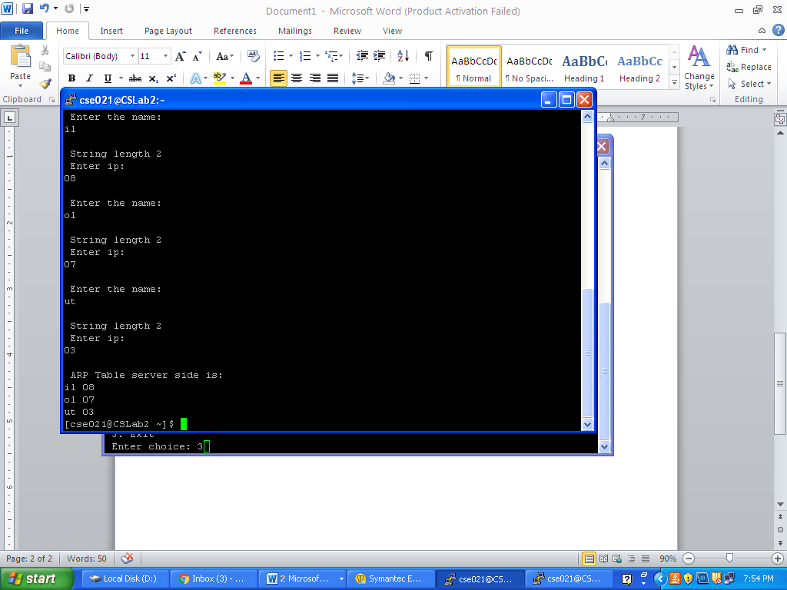
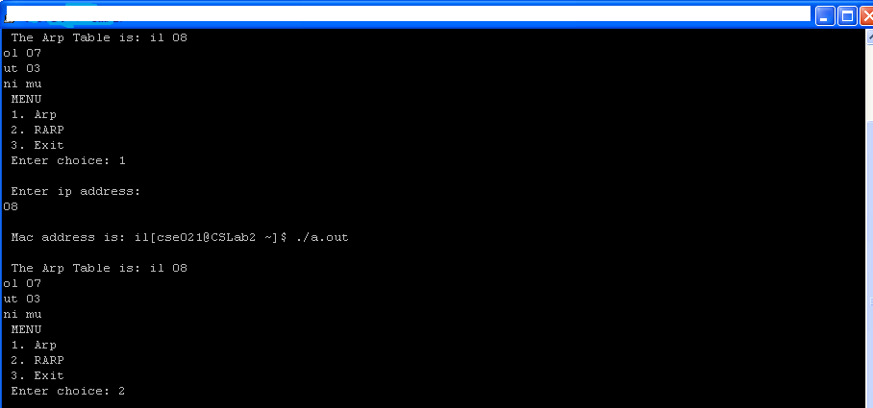

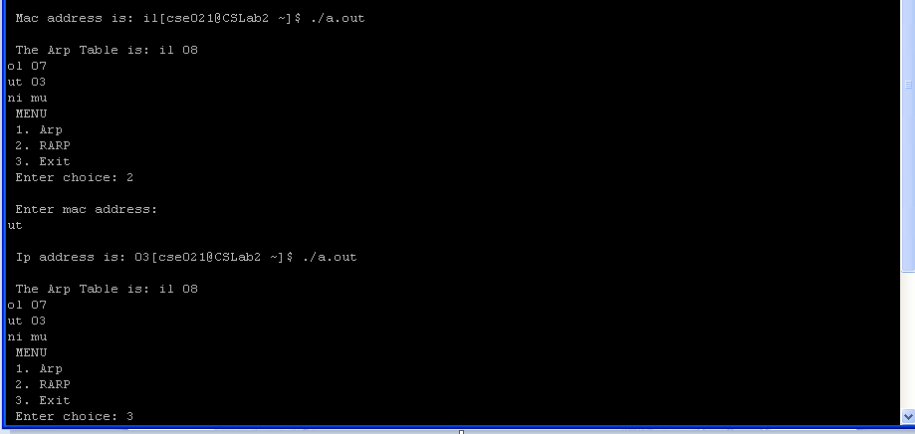

RESULT
The address resolution protocol has been achieved .

5.SIMULATION OF PING AND TRACEROUTE COMMANDS

AIM
To write a program to simulate PING| and TRACEROUTE commands.

OBJECTIVE
To understand how PING and TRACEROUTE command works.

SOFTWARE REQUIRED
1) OS – WindowsXP
2) Turbocpp

DESCRIPTION

The Ping Command
The ping command is a very common method for troubleshooting the accessibility of devices. It uses a series of Internet Control Message Protocol (ICMP) Echo messages to determine:
- Whether a remote host is active or inactive.
- The round-trip delay in communicating with the host.
- Packet loss.
The ping command first sends an echo request packet to an address, then waits for a reply. The ping is successful only if:
- The echo request gets to the destination, and
- The destination is able to get an echo reply back to the source within a predetermined time called a timeout. The default value of this timeout is two seconds on Cisco routers.
The TTL value of a ping packet cannot be changed.

The Traceroute Command
The traceroute command is used to discover the routes that packets actually take when traveling to their destination. The device (for example, a router or a PC) sends out a sequence of User Datagram Protocol (UDP) datagrams to an invalid port address at the remote host.
Three datagrams are sent, each with a Time-To-Live (TTL) field value set to one. The TTL value of 1 causes the datagram to "timeout" as soon as it hits the first router in the path; this router then responds with an ICMP Time Exceeded Message (TEM) indicating that the datagram has expired.
Another three UDP messages are now sent, each with the TTL value set to 2, which causes the second router to return ICMP TEMs. This process continues until the packets actually reach the other destination. Since these datagrams are trying to access an invalid port at the destination host, ICMP Port Unreachable Messages are returned, indicating an unreachable port; this event signals the Traceroute program that it is finished.
This is used to record the source of each ICMP Time Exceeded Message to provide a trace of the path the packet took to reach the destination.

ALGORITHM

1) Start the Program.
2) Get an IP address..
3) Using Buffered Reader stream the IP is stored as string.
4) The Process package helps to execute the commands ..
5) Display the contents to the user.
6) Stop the program.

PROGRAM:
import java.io.*;
import java.net.*;
class trace
{ public static void main(String args[])
{try
{String str,str2;
System.out.print(" Enter the IP Address to be traced: ");
BufferedReader buf1=new BufferedReader(new
InputStreamReader(System.in));
String ip=buf1.readLine();
Runtime H=Runtime.getRuntime();
Process p=H.exec("tracert " + ip);
Process p1=H.exec("ping " + ip);
InputStream in=p.getInputStream();
InputStream in1=p1.getInputStream();
BufferedReader buf2=new BufferedReader(new
InputStreamReader(in));
BufferedReader buf3=new BufferedReader(new
InputStreamReader(in1));
while((str=buf2.readLine())!=null)
{System.out.println(" " + str);
}
while((str=buf3.readLine())!=null)
{
System.out.println(" " + str);
}
}
catch(Exception e)
{
System.out.println(e.getMessage());
}
}
}

OUTPUT:

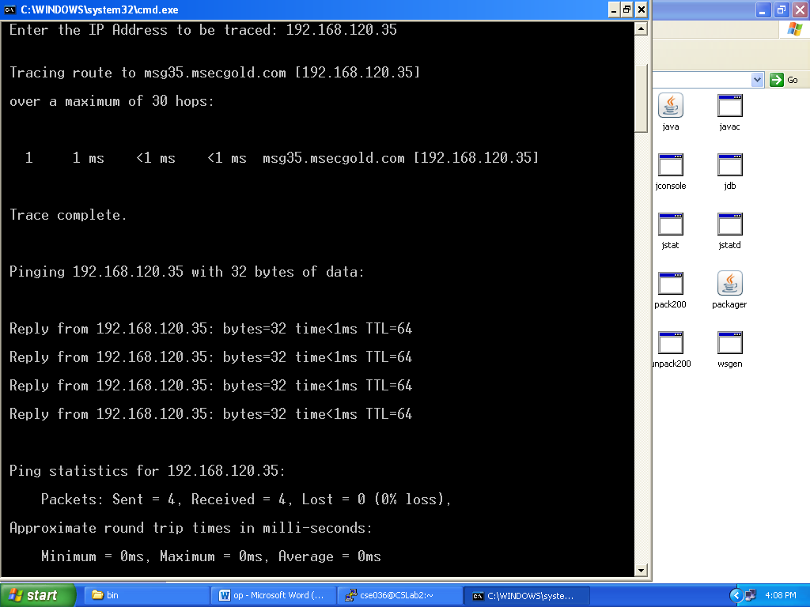

RESULT
A program for simulating PING and TRACEROUTE commands have been written and executed.

6.IMPLEMENTATION OF UPLOADING AND DOWNLOADING A PAGE

AIM
To write a program to simulate PING| and TRACEROUTE commands.

OBJECTIVE
To understand how PING and TRACEROUTE command works.

SOFTWARE REQUIRED
1) OS – WindowsXP
2) Turbocpp

DESCRIPTION:
To download an image or page, we use java class URL. To upload an image to a web server, we convert Buffered Image to byte array to send it to server.
The Java.io.InputStream class is super stream class of all classes representing an input stream of bytes. The Java.io.DataInputStream class lets an application read primitive Java data types from an underlying input stream.
JavaBufferedImage class, a subclass of Image, is used to handle and manipulate image data. Class JFrame is an extended version of java.awt.Frame that adds support for component architecture. The class Image Icon is implementation of Icon interface that paints Icons from Images. Class JLabel can display either text or image or both. Labels are vertically centered.
The ByteArrayOutputSream creates a buffer in memory. All data sent to the stream is stored in the buffer. The java.io.BufferedInputStream.flush() flushes buffered output bytes to write out to output stream. The baos.toByteArray() method creates a newly allocated buffer with current size of output stream. The DataOutputStream lets you write primitives to an output source.
ALGORITHM :
1) Start the Program.
2) A socket is created on the client side.
3) An image is being selected and sent to the server .
4) A socket on the server side receives this image.
5) Display the contents to the user.
6) Stop the program.

PROGRAM:
CLIENT
import javax.swing.*;
import java.net.*;
import java.awt.image.*;
import javax.imageio.*;
import java.io.*;
import java.awt.image.BufferedImage;
import java.io.ByteArrayOutputStream;
import java.io.File;
import java.io.IOException;
import javax.imageio.ImageIO;

public class Client{
public static void main(String args[]) throws Exception{
Socket soc;
BufferedImage img = null;
soc=new Socket("localhost",4000);
System.out.println("Client is running. ");
try {
System.out.println("Reading image from disk. ");
img = ImageIO.read(new File("photo.jpg"));
ByteArrayOutputStream baos = new ByteArrayOutputStream();
ImageIO.write(img, "jpg", baos);
baos.flush();
byte[] bytes = baos.toByteArray();
baos.close();
System.out.println("Sending image to server. ");
OutputStream out = soc.getOutputStream();
DataOutputStream dos = new DataOutputStream(out);
dos.writeInt(bytes.length);
dos.write(bytes, 0, bytes.length);
System.out.println("Image sent to server. ");

dos.close();
out.close();
}catch (Exception e) {
System.out.println("Exception: " + e.getMessage());
soc.close();
}
soc.close();
}
}
SERVER
import java.net.*;
import java.io.*;
import java.awt.image.*;
import javax.imageio.*;
import javax.swing.*;

class Server {
public static void main(String args[]) throws Exception{
ServerSocket server=null;
Socket socket;
server=new ServerSocket(4000);
System.out.println("Server Waiting for image");
socket=server.accept();
System.out.println("Client connected.");
InputStream in = socket.getInputStream();
DataInputStream dis = new DataInputStream(in);
int len = dis.readInt();
System.out.println("Image Size: " + len/1024 + "KB");
byte[] data = new byte[len];
dis.readFully(data);
dis.close();
in.close();
InputStream ian = new ByteArrayInputStream(data);
BufferedImage bImage = ImageIO.read(ian);
JFrame f = new JFrame("Server");
ImageIcon icon = new ImageIcon(bImage);
JLabel l = new JLabel();
l.setIcon(icon);
f.add(l);
f.pack();
f.setVisible(true);
}}

OUTPUT:
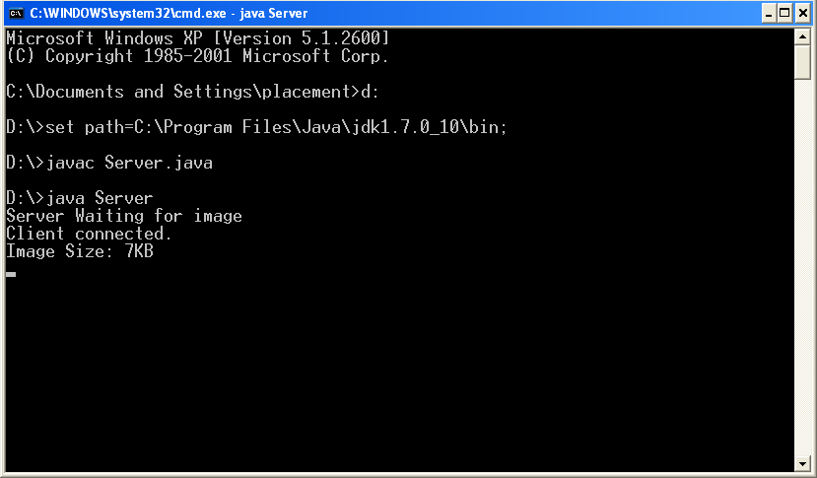

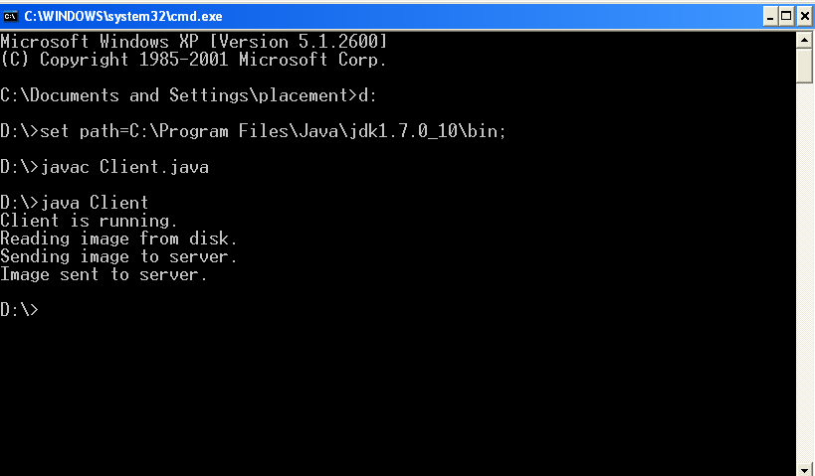

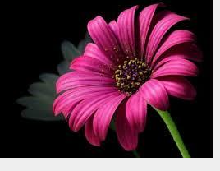

RESULT:
A Program is written using socket for uploading and downloading an image.
7. IMPLEMENTATION OF REMOTE PROCEDURE CALL (RPC)

AIM
To write a program to implement the remote procedure call.

OBJECTIVE
To understand about the communication using remote procedure call.

SOFTWARE REQUIREMENTS
1. OS – Windows XP
2 .Java Development Kit (JDK)

DESCRIPTION
Remote Procedure Call (RPC) is a protocol that one program can use to request a service from a program located in another computer in a network without having to understand network details.RPC uses the client/server model. RPC is initiated by a client. In RPC, while a server is processing the call, the client is blocked unless the client sends an asynchronous request to the server.
When program statements that use RPC are compiled into an executable program, a stub is included in the compiled code that acts as the representative of the remote procedure code. When the program is run and the procedure call is issued, the stub receives the request and forwards it to a client runtime program in the local computer. The client runtime program has the knowledge of how to address the remote computer and server application and sends the message across the network that requests the remote procedure. Similarly, the server includes a runtime program and stub that interface with the remote procedure itself. Results are returned the same way.
ALGORITHM
1) Define the interface for the remote class.
2) Create and compile implementation class for remote object.
3) Create stub and skeleton class using rmi command.
4) Create and compute a client program to access the remote object.
5) Test the class and execute.
6) Display the result.

PROGRAM:
ADDSERVERINTF
import java.rmi.*;
public interface AddServerIntf extends Remote
{
double fact(double d1)throws RemoteException;
}
ADDSERVERIMPL
import java.rmi.*;
import java.rmi.server.*;
public class AddServerImpl extends UnicastRemoteObject
implements AddServerIntf
{
public AddServerImpl() throws RemoteException
{
}
public double fact(double d1)throws RemoteException
{ double i,f=1;
for(i=1;i<=d1;i++)
{ f=f*i; }
return f;
}}

ADDSERVER
import java.net.*;
import java.rmi.*;
public class AddServer
{
public static void main(String args[])
{ try
{
AddServerImpl addServerImpl=new AddServerImpl();
Naming.rebind("AddServer",addServerImpl);
}
catch(Exception e)
{
System.out.println("Exception:"+e);
} } }

ADDCLIENT
import java.rmi.*;
public class AddClient
{
public static void main(String args[])
{
try
{
String addServerURL="rmi://"+args[0]+"/AddServer";
AddServerIntf addServerIntf=(AddServerIntf)Naming.lookup(addServerURL);
System.out.println("The first number is"+args[1]);
double d1=Double.valueOf(args[1]).doubleValue();
System.out.println("The second number is"+args[2]);
double d2=Double.valueOf(args[2]).doubleValue();
System.out.println("The result is"+addServerIntf.pwr(d1,d2));
}
catch(Exception e)
{
System.out.println("Exception:"+e);
}
}
}
OUTPUT:
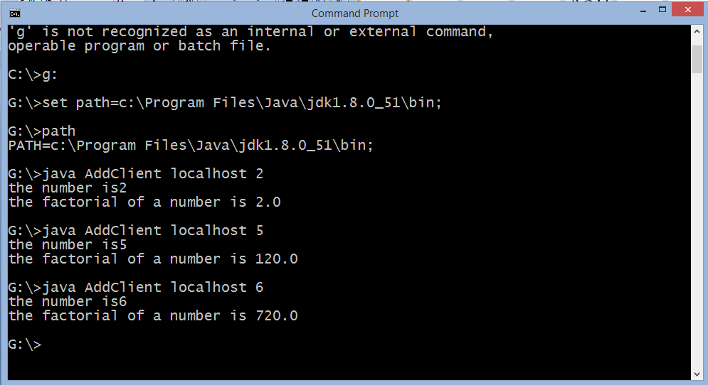

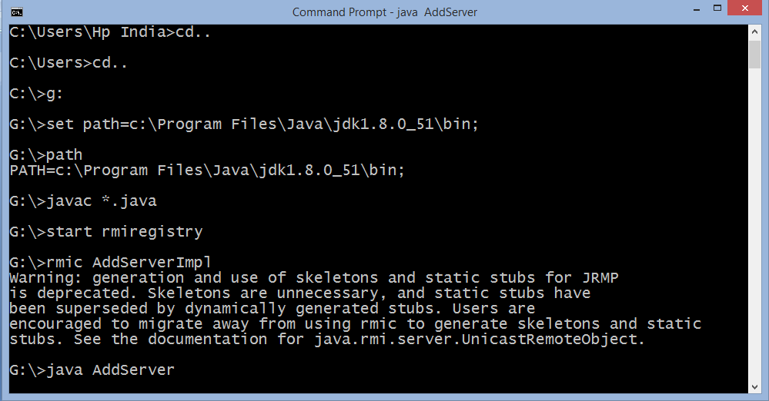

RESULT
A program for addition of two numbers is written to implement the working of remote procedure call.

8. IMPLEMENTATION OF SUBNETTING

AIM

To write a program to perform Subnetting.

OBJECTIVE
To understand the process of dividing large networks into subnets based on IP address.

SOFTWARE REQUIREMENTS
Turbo Cpp

DESCRIPTION :

Subnetting is a process of dividing large networks into smaller networks based on IP addresses.
Class A: 1 - 126
Class B: 127 – 191
Class C: 192 – 223
Class D: 224 – 239
Class E: 240 – 254
Subnet mask: 32-bit address used to separate network and host IP address.
Decimal: 0 represents host address. 1 – 255 represent network address.
Binary: 0 represents host address. 1 represents network address.
Eg: IP: 192.168.1.10
Here 10 represent host address.
Class Network Bits Host Bits Total Hosts Valid Hosts
A 255.0.0.0 First 8 bits Last 24 bits 16777126
B 255.255.0.0 First 16 bits Last 16 bits 65536
C 255.255.255.0 First 24 bits Last 8 bits 256
Subnetting is the process of breaking large networks into small networks called subnets.
Eg: Suppose two networks are to be created within 30 systems each in class C. If we use them, then two classes’ IP range should be used. Class C has 256 addresses. But we require only 30 requests. So there is wastage of 226.
Subnetting happens when default subnet mask is extended.
Eg: 188.25.45.48/20
This is class B. Subnet masks for class B is 255.255.0.0.It is 16 in CIDR. But given value is /20. Thus 4 bits are borrowed from host.
Subnetting moves from left to right and no network bit is skipped.
In binary, 11111111.11111111.11110000.00000000
- 255.255.240.0 => Subnet mask
Total number of subnets is given by 2^{N} where N is the number of bits borrowed from network to create subnets.
Here, N=4 => 2^{N} = 32 subnets.
PROGRAM:
#include<stdio.h>
#include<conio.h>
#include<iostream.h>
#include<string.h>
#include<ctype.h>
#include<stdlib.h>
#include<math.h>
void main()
{
char ip[50],ip1[50]=" ",ip2[50]=" ",ip3[50]=" ",ip4[50]=" ",ch;
inti,m,n=0,j,k,l,s1,s2,s3,s4,c1[50],c2[50],c3[50],c4[50];
int b1[50],b2[50],b3[50],b4[50],q1=0,q2=0,q3=0,q4=0,c[50];
int d1[50],d2[50],d3[50],d4[50],z=0,v=0;
int sum1=0,sum2=0,sum3=0,sum4=0;
clrscr();
k=j=l=0;
cout<<"\n Enter the IP Address:";
cin>>ip;
i=0;
while(ip[i]!='.')
{
ip1[i]=ip[i];
i++;
}
i++;
while(ip[i]!='.')
{
ip2[j]=ip[i];
i++; j++;
}
i++;
while(ip[i]!='.')
{
ip3[k]=ip[i];
i++; k++;
}
i++;
while(ip[i]!='\0')
{
ip4[l]=ip[i];
i++; l++;
}
cout<<"The first part of IP is:"<<ip1;
cout<<"\n The second part of IP is:"<<ip2;
cout<<"\n the third part of ip is:"<<ip3;
cout<<"\n the fourth part of ip is:"<<ip4;
s1=atoi(ip1);
s2=atoi(ip2);
s3=atoi(ip3);
s4=atoi(ip4);
if((s1>1) &&(s1<=126))
{
cout<<"\n belongs to class A:";
ch='a';
}
else if((s1>=126) &&(s1<=191))
{
cout<<"\n Belongs to class B:";
ch='b';
}
else if((s1>=191) && (s1<=223))
{
cout<<"\n Belongs to class c";
ch='c';
}
else
{
cout<<"\n Belongs to class D";
ch='d';
}
i=0;
q1=s1;
while(q1!=0)
{
c1[i]=q1%2;
q1=q1/2;
i++;
}
for(j=i-1;j>=0;j--)
printf("%d",c1[j]);
printf(".");
for(k=0,j=i;j>=0,k<=i;j--,k++)
b1[k]=c1[j];
i=0;
q2=s2;
while(q2!=0)
{
c2[i]=q2%2;
q2=q2/2;
i++;
}
for(j=i-1;j>=0;j--)
printf("%d",c2[j]);
printf(".");
for(k=0,j=i;j>=0,k<=i;j--,k++)
b2[k]=c2[j];
i=0;
q3=s3;
while(q3!=0)
{
c3[i]=q3%2;
q3=q3/2;
i++;
}
for(j=i-1;j>=0;j--)
printf("%d",c3[j]);
printf(".");
for(k=0,j=i;j>=0,k<=i;j--,k++)
b3[k]=c3[j];
i=0;
q4=s4;
while(q4!=0)
{
c4[i]=q4%2;
q4=q4/2;
i++;
}
for(j=i-1;j>=0;j--)
printf("%d",c4[j]);
for(k=0,j=i;j>=0,k<=i;j--,k++)
b4[k]=c4[j];
switch(ch)
{
case 'c':
cout<<"\n The masked address in binary is :11111111.11111111.11111111.";

for(i=0;i<k;i++)
cout<<"0";
cout<<"\n Enter the mask value(>24)";
cin>>m;
n=m-24;
cout<<"\n The ip is:11111111.11111111.11111111.";
for(z=0;z<8;z++)
{
d1[z]=1;
d2[z]=1;
d3[z]=1;
}
z=0;
for(i=0;i<n;i++,z++)
{ d4[z]=1;
cout<<"1";
}
//z++;
for(i=0;i<8-n;i++,z++)
{d4[z]=0;
cout<<"0";
}
break;
case 'b':
cout<<"\n The masked address in binary is: 11111111.11111111.";
for(i=0;i<k;i++)
cout<<"0";
cout<<".";
for(i=0;i<k;i++)
cout<<"0";
cout<<"\n Enter the mask value(>16)";
cin>>m;
n=m-16;
cout<<"\n The ip is:11111111.11111111.";
for(z=0;z<8;z++)
{
d1[z]=1;
d2[z]=1;
}
z=0;
for(i=0;i<n;i++,z++)
{d3[z]=1;
cout<<"1";
}
for(i=0;i<8-n;i++,z++)
{d3[z]=0;
cout<<"0";
}
z=0;
cout<<".";
for(i=0;i<k;i++,z++)
{ d4[z]=0;
cout<<"0";
}
break;
case 'a':
cout<<"\n The masked address in binary is:11111111.";
for(i=0;i<k;i++)
cout<<"0";
cout<<".";
for(i=0;i<k;i++)
cout<<"0";
cout<<".";
for(i=0;i<k;i++)
cout<<"0";
cout<<"\n Enter the mask value(>8)";
cin>>m;
n=m-8;
cout<<"\n The ip is:11111111.";
for(z=0;z<8;z++)
d1[z]=1;
z=0;
for(i=0;i<n;i++,z++)
{d2[z]=1;
cout<<"1";
}
for(i=0;i<8-n;i++,z++)
{d2[z]=0;
cout<<"0";
}
z=0;
cout<<".";
for(i=0;i<k;i++,z++)
{d3[z]=0;
cout<<"0";
}
z=0;
cout<<".";
for(i=0;i<k;i++,z++)
{
d4[z]=0;
cout<<"0";
}
break;
case 'd':
cout<<"\n THe masked address in binary is :11111111.11111111.11111111.11111111";
break;
}
i=0;
cout<<"\n The masked ip in decimal is:";
for(i=7,v=0;i>=0;i--,v++)
sum1=sum1+d1[v]*pow(2,i);
cout<<sum1<<".";
i=0;
for(i=7,v=0;i>=0;i--,v++)
sum2=sum2+d2[v]*pow(2,i);
cout<<sum2<<".";
i=0;
for(i=7,v=0;i>=0;i--,v++)
sum3=sum3+d3[v]*pow(2,i);
cout<<sum3<<".";
i=0;
for(i=7,v=0;i>=0;i--,v++)
sum4=sum4+d4[v]*pow(2,i);
cout<<sum4;
getch();
}

OUTPUT:
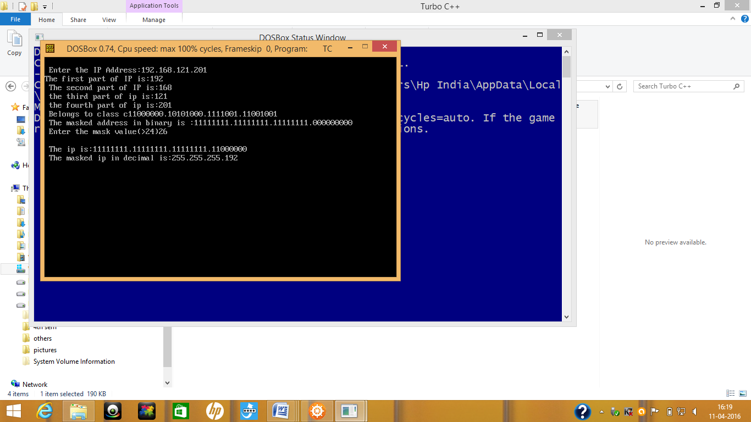

Result :.
A program is executed successfully to convert the given IP address into subnets

9.IMPLEMENTATION OF ECHO CLIENT SERVER

AIM

To write a program to perform client server ECHO application.

OBJECTIVE
To understand the client-server ECHO application using TCP.

SOFTWARE REQUIREMENTS
1. Local network – Telnet/ Cygwin application

DESCRIPTION
An ECHOt application consists of a echo server and a echo client. The server accepts connections from the clients and delivers all messages from each client to other clients. This is a tool to communicate with other people over Internet in real time.
The client is implemented using two threads - one thread to interact with the server and the other with the standard input. Two threads are needed because a client must communicate with the server and, simultaneously, it must be ready to read messages from the standard input to be sent to the server.
The server is implemented using threads also. It uses a separate thread for each connection. It spawns a new client thread every time a new connection from a client is accepted. This simplifies a lot the design of the server. Multi-threading, however, creates synchronization issues. We will present two implementations of the chat server. An implementation that focus on multi-threading without considering the synchronization issues will be presented first. Then we will focus on the synchronization issues that a multi-threaded implementation creates. Finally, an updated version of the multi-threaded chat server that fixes the synchronization issues is presented.

ALGORITHM:
Step 1: Start the program.
Step 2: Establish the connection between the client and the server.
Step 3: Identify the Server address, family and port number.
Step 4: Create Socket to send the message
Step 5: Bind the connection
Step 6: Confirm the connection between the client and the server
Step 7: Create a buffer to send and receive the message
Step 8: Start sending the messages to and from the client and server
Step 9: Repeat the steps 4 to 8 until the connection is terminated.
Step 10: Stop the program.

PROGRAM

CLIENT

#include<sys/socket.h>
#include<netinet/in.h>
#include<netdb.h>
#define SERV_TCP_PORT 5003
int main(int argc, char *argv[])
{ int sockfd;
struct sockaddr_in serv_addr;
struct hostnet *server;
char buffer[4096];
sockfd = socket(AF_INET,SOCK_STREAM,0);
serv_addr.sin_family = AF_INET;
serv_addr.sin_addr.s_addr = inet_addr("127.0.0.1");
serv_addr.sin_port = htons(SERV_TCP_PORT);
connect(sockfd,(struct sockaddr *)&serv_addr,sizeof(serv_addr));
printf("\nenter the message:\n");
bzero(buffer,4096);
printf("\nclient:");
fgets(buffer,4096,stdin);
write(sockfd,buffer,4096);
bzero(buffer,4096);
read(sockfd,buffer,4096);
printf("\nserver msg :%s",buffer);
printf("\n");
close(sockfd);
return 0;
}

SERVER
#include<stdio.h>
#include<sys/types.h>
#include<sys/socket.h>
#include<netinet/in.h>
#include<netdb.h>
#define SERV_TCP_PORT 5003
int main(int argc, char *argv[])
{int sockfd, newsockfd, clength;
struct sockaddr_in serv_addr, cli_addr;
char buffer[4096];
sockfd = socket(AF_INET,SOCK_STREAM,0);
serv_addr.sin_family = AF_INET;
serv_addr.sin_addr.s_addr = INADDR_ANY;
serv_addr.sin_port = htons(SERV_TCP_PORT);
bind(sockfd,(struct sockaddr *)&serv_addr, sizeof(serv_addr));
listen(sockfd,5);
clength = sizeof(cli_addr);
newsockfd = accept(sockfd,(struct sockaddr *)&cli_addr, &clength);
bzero(buffer,4096);
read(newsockfd,buffer,4096);
printf("\nclient message: %s",buffer);
write(newsockfd,buffer,4096);
printf("\n");
close(sockfd);
return 0;
}

OUTPUT

CLIENT SIDE

Enter the message:

Client:

Hai

Server message:

Hai

SERVER SIDE

Client message:

Hai

RESULT
A program for client server ECHO application has been executed.

10.IMPLEMENTATION OF CHAT CLIENT SERVER

AIM

To write a program to perform client server chat application.

OBJECTIVE
To understand the client-server chat application using TCP.

SOFTWARE REQUIREMENTS
1. Local network – Telnet/ Cygwin application

DESCRIPTION
A chat application consists of a chat server and a chat client. The server accepts connections from the clients and delivers all messages from each client to other clients. This is a tool to communicate with other people over Internet in real time.
The client is implemented using two threads - one thread to interact with the server and the other with the standard input. Two threads are needed because a client must communicate with the server and, simultaneously, it must be ready to read messages from the standard input to be sent to the server.
The server is implemented using threads also. It uses a separate thread for each connection. It spawns a new client thread every time a new connection from a client is accepted. This simplifies a lot the design of the server. Multi-threading, however, creates synchronization issues. We will present two implementations of the chat server. An implementation that focus on multi-threading without considering the synchronization issues will be presented first. Then we will focus on the synchronization issues that a multi-threaded implementation creates. Finally, an updated version of the multi-threaded chat server that fixes the synchronization issues is presented.

ALGORITHM:
Step 1: Start the program.
Step 2: Establish the connection between the client and the server.
Step 3: Identify the Server address, family and port number.
Step 4: Create Socket to send the message
Step 5: Bind the connection
Step 6: Confirm the connection between the client and the server
Step 7: Create a buffer to send and receive the message
Step 8: Start sending the messages to and from the client and server
Step 9: Repeat the steps 4 to 8 until the connection is terminated.
Step 10: Stop the program.

PROGRAM:
Client:
#include<stdio.h>
#include<string.h>
#include<netdb.h>
#include<stdlib.h>
int main()
{
charbuf[100];
int k;
intsock_desc;
structsockaddr_in client;
memset(&client,0,sizeof(client));
sock_desc=socket(AF_INET,SOCK_STREAM,0);
if(sock_desc==-1)
{
printf("Error in socket creation");
exit(1);
}
client.sin_family=AF_INET;
client.sin_addr.s_addr=INADDR_ANY;
client.sin_port=3002;
k=connect(sock_desc,(structsockaddr*)&client,sizeof(client));
if(k==-1)
{
printf("Error in connecting to server");
exit(1);
}
while(1)
{
printf("\nEnter data to be send to server: ");
fgets(buf,100,stdin);
if(strncmp(buf,"end",3)==0)//Use .end. to end communication with server
break;
k=send(sock_desc,buf,100,0);
if(k==-1)
{
printf("Error in sending");
exit(1);
}
k=recv(sock_desc,buf,100,0);
if(k==-1)
{
printf("Error in receiving");
exit(1);
}
printf("Message got from server is : %s",buf);
}
close(sock_desc);
exit(0);
return 0;
}

Server:
#include<sys/socket.h>
#include<stdio.h>
#include<string.h>
#include<netdb.h>
#include<stdlib.h>
int main()
{
charbuf[100];
int k;
socklen_tlen;
intsock_desc,temp_sock_desc;
structsockaddr_inserver,client;
memset(&server,0,sizeof(server));
memset(&client,0,sizeof(client));
sock_desc=socket(AF_INET,SOCK_STREAM,0);
if(sock_desc==-1)
{
printf("Error in socket creation");
exit(1);
}
server.sin_family=AF_INET;
server.sin_addr.s_addr=inet_addr("127.0.0.1");
server.sin_port=3002;
k=bind(sock_desc,(structsockaddr*)&server,sizeof(server));
if(k==-1)
{
printf("Error in binding");
exit(1);
}
k=listen(sock_desc,20);
if(k==-1)
{
printf("Error in listening.");
exit(1);
}
len=sizeof(client);//VERY IMPORTANT
temp_sock_desc=accept(sock_desc,(structsockaddr*)&client,&len);//VERY //IMPORTANT
if(temp_sock_desc==-1)
{printf("Error in temporary socket creation");
exit(1);
}
while(1)
{
k=recv(temp_sock_desc,buf,100,0);
if(k==-1)
{
printf("Error in receiving");
exit(1);
}
printf("Message got from client is : %s",buf);
printf("\nEnter data to be send to client: ");
fgets(buf,100,stdin);
if(strncmp(buf,"end",3)==0)
break;
k=send(temp_sock_desc,buf,100,0);
if(k==-1)
{
printf("Error in sending");
exit(1);
}
}
close(temp_sock_desc);
exit(0);
return 0;
}

OUTPUT:

SERVER:

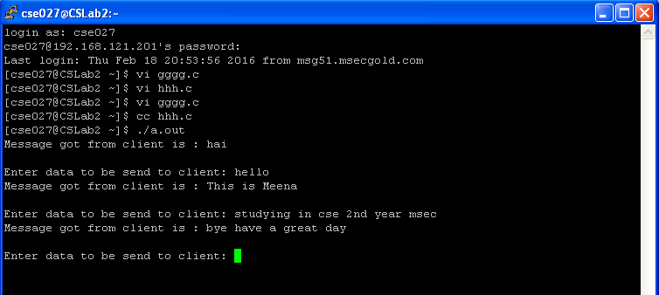

CLIENT:
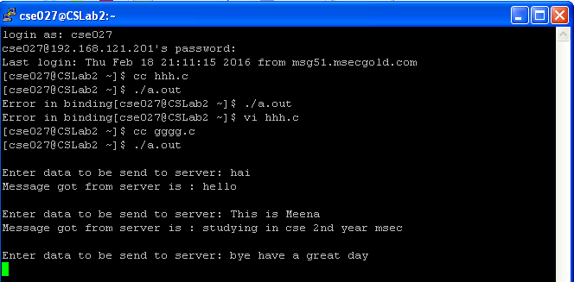

RESULT
A program for client server chat application has been executed
11. IMPLEMENTATION OF FILE TRANSFER USING TCP

AIM
To write a C program for transferring a file using Transmission Control Protocol(TCP).

OBJECTIVE
To understand the procedure of transferring files using Transmission Control Protocol(TCP).

SOFTWARE REQUIRED
1) OS – WindowsXP
2) Turbocpp

DESCRIPTION
The File Transfer Protocol (FTP) is a standard network protocol used to transfer computer files from one host to another host over a TCP-based network, such as the Internet. FTP is built on a client-server architecture and uses separate control and data connections between the client and the server. FTP users may authenticate themselves using a clear-text sign-in protocol, normally in the form of a username and password, but can connect anonymously if the server is configured to allow it. For secure transmission that protects the username and password, and encrypts the content, FTP is often secured with SSL/TLS (FTPS). SSH File Transfer Protocol (SFTP) is sometimes also used instead.
ALGORITHM
SERVER
1) Start the program.
2) Create an unnamed socket for the server using parameters AF_INET as domain and SOCK_STREAM as type.
3) Get the server port number.
4) Register the host address to the system by using bind() system call in server side.
5) Create a connection queue and wait for clients using listen() system call with the number of clients requests as parameter.
6) Create a Child process using fork( ) system call.
7) If the process identification number is equal to zero accept the connection using accept( ) system call when the client request for connection.
8) If pid is not equal to zero then exit the process.
9) Stop the Program execution.

CLIENT

1) Start the program.
2) Create an unnamed socket for the client using parameters AF_INET as domain and SOCK_STREAM as type.
3) Get the client port number.
4) Now connect the socket to server using connect( ) system call.
5) Enter the file name.
6) The file is transferred from client to server using send ( ) function.
7) Print the contents of the file in a new file.
8) Stop the program.

PROGRAM
SERVER
#include<stdio.h>
#include<sys/types.h> #include<netinet/in.h> #include<string.h>
main()
{
FILE *fp;
int sd,newsd,ser,n,a,cli,pid,bd,port,clilen;
char name[100],fileread[100],fname[100],ch,file[100],rcv[100]; struct sockaddr_in servaddr,cliaddr;
printf("Enter the port address: "); scanf("%d",&port);
sd=socket(AF_INET,SOCK_STREAM,0); if(sd<0)
printf("Can't Create \n"); else
printf("Socket is Created\n");
servaddr.sin_family=AF_INET; servaddr.sin_addr.s_addr=htonl(INADDR_ANY); servaddr.sin_port=htons(port); a=sizeof(servaddr);
bd=bind(sd,(struct sockaddr*)&servaddr,a); if(bd<0)
printf(" Can't Bind\n"); else
printf("\n Binded\n");
listen(sd,5); clilen=sizeof(cliaddr);
newsd=accept(sd,(struct sockaddr*)&cliaddr,&clilen); if(newsd<0)
printf("Can't Accept\n"); else
printf("Accepted\n");
n=recv(newsd,rcv,100,0); rcv[n]='\0'; fp=fopen(rcv,"r"); if(fp==NULL)
send(newsd,"error",5,0);
close(newsd);
else
while(fgets(fileread,sizeof(fileread),fp))
if(send(newsd,fileread,sizeof(fileread),0)<0)
printf("Can't send\n");
sleep(1);
if(!fgets(fileread,sizeof(fileread),fp))
send(newsd,"completed",999999999,0);
return 0;
}

CLIENT
#include<stdio.h> #include<sys/socket.h> #include<netinet/in.h>
main()
{
FILE *fp;
int csd,n,ser,s,cli,cport,newsd;
char name[100],rcvmsg[100],rcvg[100],fname[100]; struct sockaddr_in servaddr;
printf("Enter the port"); scanf("%d",&cport);
csd=socket(AF_INET,SOCK_STREAM,0);
if(csd<0)
printf("Error..."); exit(0);
else
printf("Socket is Created...\n");
servaddr.sin_family=AF_INET; servaddr.sin_addr.s_addr=htonl(INADDR_ANY);servaddr.sin_port=htons(cport);
if(connect(csd,(struct sockaddr*)&servaddr,sizeof(servaddr))<0) printf("Error in Connection...\n");
else printf("Connected...\n");
printf("Enter the existing file name: "); scanf("%s",name);
printf("\nEnter the new filename: ");
scanf("%s",fname);
fp=fopen(fname,"w"); send(csd,name,sizeof(name),0);
while(1)
s=recv(csd,rcvg,100,0); rcvg[s]='\0'; if(strcmp(rcvg,"error")==0) printf("File is not Available...\n");
if(strcmp(rcvg,"completed")==0) printf("file is transferred...\n"); fclose(fp); close(csd); break;
else
fputs(rcvg,stdout);
fprintf(fp,”%s”,rcvg);
}

OUTPUT
Server Side

Enter the port address: 8663
Socket is Created Binded Connected…

Client Side

Socket is Created..
Connected
Enter the existing file name: net Enter the new file name: network Welcome to Network Lab
File is transferred...

RESULT
A C program for transferring file from one machine to another machine using TCP is executed.

12. IMPLEMENTATION OF DOMAIN NAME SYSTEM

AIM
To implement the domain name system .

OBJECTIVE
To understand the concept of domain name system.
SOFTWARE REQUIREMENTS
1. OS – Windows XP
2. Network Protocol - Telnet

DESCRIPTION
The Domain Name System (DNS) uses a hierarchical naming system for computers, services, or any resource connected to the Internet or a private network. It associates various information with domain names assigned to each of the participating entities. It also has a table containing namespace which is partitioned into disjoint pieces and distributed through the Internet.
Each datagram that is to be transmitted has an IP address but not the domain name. This IP address does the process of forwarding at each router. The IP also engages ARP to translate next hop IP address into physical address for that MAC. Thus DNS translates more readily memorized domain names to the numerical IP addresses. Various applications use DNS to find IP addresses for locating and identifying computer services.
It is found that UDP is more efficient than TCP because to start a TCP connection, a minimum of three packets (SYN out, SYN + ACK back, ACK out) are required. By the time the data packet is added and the session is closed off correctly, you could have sent several packets. But UDP requires a minimum of two packets only.
The servent structure, defined in the NETDB.H header file, specifies or obtains a service name, a list of aliases associated with the service, and the service's number specified as an Internet address from the services database. An entry in the services database is created with the following TCP/IP management command:
SET SERVICE service
The servent structure members are as follows:
- s_name is the official name of the service.
- s_aliases is a null-terminated list of pointers to alternate names for the service.
- s_port is the port number at which the service resides in network byte order.
- s_proto is the name of the protocol to use with the service.
Some of the registered ports are:
- 1027 Native IPv6 behind IPv4-to-IPv4 NAT Customer Premises Equipment
- 1194 OpenVPN
- 6515 Elipse RPC Protocol (REC)

The getservbyname() and getservbyport() functions return a pointer to a servent structure, the members of which contain the fields of an entry in network servcol database.
The getservbyname() function searches the database and finds an entry which matches the specified service name and the specified protocol, opening a connection to the database if necessary.
The getservbyport() function searches the database and finds an entry which matches the specified port number and the specified protocol, opening a connection to the database if necessary.

ALGORITHM
1) Create a new file, enter domain name and address in that file.
2) Get the domain name as input from the user.
3) The domain name corresponding to IP address is displayed.
4) Stop the program.

PROGRAM:
#include<stdio.h>
#include<string.h>
#include<stdlib.h>
#include<unistd.h>
#include<sys/socket.h>
#include<sys/types.h>
#include<netinet/in.h>
#include<arpa/inet.h>
#include<fcntl.h>
#include<errno.h>
#include<netdb.h>
int main()
{
charserv[50],proto[50];
int port;
structservent *sptr;
printf("\n Enter the service name: ");
scanf("%s",&serv);
printf("\n Enter the protocol used: ");
scanf("%s",&proto);
if((sptr=(getservbyname(serv,proto)))==NULL)
{
perror("\n getserv by name error ");
}
printf("\n Registered port no. : %d",sptr->s_port);
printf("\n Enter port no: ");
scanf("%d",&port);
printf("\n protocol used: ");
printf("%s",proto);
printf("\n service name is ");
printf("%s",serv);
if((sptr=getservbyport(port,proto))==NULL)
{
perror("\n getserv by port error");
}
return 0;
}

OUTPUT:
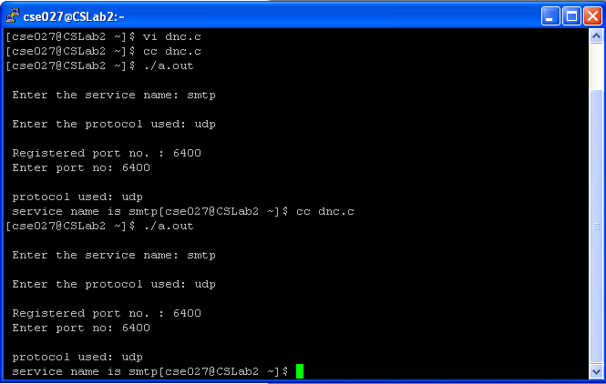

RESULT
A program is written to implement the domain name system.

13. IMPLEMENTATION OF SIMPLE NETWORK MANAGEMENT PROTOCOL

AIM
To write a C program for simulation of Simple Network management Protocols using Transmission Control Protocol.

OBJECTIVE
To understand the operation of SNMP protocol and to simulate the protocol.

SOFTWARE REQUIRED
1) OS – WindowsXP
2) Turbocpp

DESCRIPTION
Simple Network Management Protocol (SNMP) is an Internet-standard protocol for managing devices on IP networks. Devices that typically support SNMP include routers, switches, servers, workstations, printers, modem racks and more. SNMP is used mostly in network management systems to monitor network-attached devices for conditions that warrant administrative attention. SNMP is a component of the Internet Protocol Suite as defined by the Internet Engineering Task Force (IETF). It consists of a set of standards for network management, including an application layer protocol, a database schema, and a set of data objects.
SNMP exposes management data in the form of variables on the managed systems, which describe the system configuration. These variables can then be queried (and sometimes set) by managing applications.
An SNMP-managed network consists of three key components:
- Managed device
- Agent — software which runs on managed devices
- Network management station (NMS) — software which runs on the manager

ALGORITHM

MANAGER

Step 1: Start the program.
Step 2: Create an unnamed socket for client using socket ( ) system.
Step 3: Call with parameters AF_INET as domain and SOCK_STREAM as type. Step 4: Name the socket using bind ( ) system call.
Step 5: Now connect the socket to agent using connect ( ) system call.
Step 6: Get the input for the type of information needed from the agent.
Step 7: If the input is equal to „TCP connection‟ then goto next step else If it is equal to „system. Goto step 9.
Step 8: Read the input for the object, send it and receive the details of the TCP connection of that object from the agent. Go to step 10.
Step 9: Read the input for the object, send it and receive the details of the system from the agent. Go to step 10.
Step 10: Receive the message, print and terminate the process. Step 11: Stop the process.

AGENTS
Step 1: Start the program.
Step 2: Create an unnamed socket for the server using the parameters AF_INET as domain and the SOCK_STREAM as type.
Step 3: Name the socket using bind( ) system call with the parameters server_sockfd and the manager address(sin_addr and sin_sport).
Step 4: Create a connection queue and wait for manager using the listen ( ) system call with the number of manager request as parameters.
Step 5: Accept the connection using accept( ) system call when manager requests for connection.
Step 6: Receive the message from the manager. If the request is for „TCP connections. Then send the details of the requested object, else if the request is for System, send the details of the requested system.
Step 7: Stop the program execution.

PROGRAM
AGENT1
#include<stdio.h> #include<sys/types.h> #include<netinet/in.h> #include<string.h>
main()
{
int i,sd,sd2,nsd,clilen,sport,len; char sendmsg[20],recvmsg[100];
char oid[5][10]="client1","client2","client3","cleint4","client5"; char wsize[5][5]="5","10","15","3","6";
struct sockaddr_in servaddr,cliaddr; printf("I'm the Agent - TCP Connection\n"); printf("\nEnter the Server port"); printf("\n_____________________\n"); scanf("%d",&sport); sd=socket(AF_INET,SOCK_STREAM,0);
if(sd<0)
printf("Can't Create \n"); else
printf("Socket is Created\n"); servaddr.sin_family=AF_INET; servaddr.sin_addr.s_addr=htonl(INADDR_ANY); servaddr.sin_port=htons(sport);
sd2=bind(sd,(struct sockaddr*)&servaddr,sizeof(servaddr)); if(sd2<0)
printf(" Can't Bind\n"); else
printf("\n Binded\n");
listen(sd,5); clilen=sizeof(cliaddr);
nsd=accept(sd,(struct sockaddr*)&cliaddr,&clilen);
if(nsd<0)
printf("Can't Accept\n"); else
printf("Accepted\n"); recv(nsd,recvmsg,100,0);
for (i=0;i<5;i++)
if(strcmp(recvmsg,oid[i])==0)
send(nsd,wsize[i],100,0);
break;

AGENT 2
#include<stdio.h> #include<sys/types.h> #include<netinet/in.h> #include<string.h>
main()
{
int i,sd,sd2,nsd,clilen,sport,len; char endmsg[20],recvmsg[100];
char oid[5][10]="System1","System2","System3","System4","System5"; char mdate[5][15]="1-10-095","10-03-8","14.03.81","11.07.07","17.12.77"; char time[5][15]="9am","10pm","11am","12.30pm","11.30am";
struct sockaddr_in servaddr,cliaddr; printf("Enter the Server port"); printf("\n_____________________\n"); scanf("%d",&sport); sd=socket(AF_INET,SOCK_STREAM,0) ;
if(sd<0)
printf("Can't Create \n"); else
printf("Socket is Created\n"); servaddr.sin_family=AF_INET; servaddr.sin_addr.s_addr=htonl(INADDR_ANY); servaddr.sin_port=htons(sport);
sd2=bind(sd,(struct sockaddr*)&servaddr,sizeof(servaddr));
if(sd2<0)
printf(" Can't Bind\n"); else
printf("\n Binded\n");
listen(sd,5); clilen=sizeof(cliaddr);
nsd=accept(sd,(struct sockaddr*)&cliaddr,&clilen);
if(nsd<0)
printf("Can't Accept\n"); else
printf("Accepted\n");
recv(nsd,recvmsg,100,0);
for(i=0;i<5;i++)
if(strcmp(recvmsg,oid[i])==0)
send(nsd,mdate[i],100,0); send(nsd,time[i],100,0); break;
}
MANAGER
#include<stdio.h> #include<sys/types.h> #include<netinet/in.h>
main() {
int csd,cport,len,i;
char sendmsg[20],rcvmsg[100],rmsg[100],oid[100]; struct sockaddr_in servaddr;
printf("Enter the port\n"); scanf("%d",&cport); csd=socket(AF_INET,SOCK_STREAM,0) ;
if(csd<0)
printf("Can't Create\n"); else
printf("Scocket is Created\n"); servaddr.sin_family=AF_INET; servaddr.sin_addr.s_addr=htonl(INADDR_ANY); servaddr.sin_port=htons(cport);
if(connect(csd,(struct sockaddr*)&servaddr,sizeof(servaddr))<0) printf("Can't Connect\n");
else
printf("Connected\n");
printf("\n 1.TCP Connection\n"); printf("\n 2. System \n");
printf("Enter the number for the type of informtion needed....\n"); scanf("%d",&i);
if(i==1)
printf("Enter the Object ID for Client\n"); scanf("%s",oid);
send(csd,oid,100,0); recv(csd,rmsg,100,0);
printf(“\N The window size of %s is %s”,oid,rmsg);
printf("\nEnter the Object ID for the System\n"); scanf("%s",oid);
send(csd,oid,100,0); recv(csd,rmsg,100,0) ;
printf("\nThe Manufacturing date for %s is %s",oid,rmsg); recv(csd,rmsg,100,0);
printf(“\n The time of last utilization for %s is %s”,oid,rmsg);}
OUTPUT
AGENT1
[cse025@localhost~]$vi agent1.c [cse025@localhost ~]$ ./a.out
I'm the Agent - TCP Connection
Enter the Server port _____________________ 8543
Socket is created Binded Accepted

MANAGER:
[cse025@localhost ~]$ ./a.out
Enter the port 8543
Socket is Created Connected
1.TCP Connection 2. System
Enter the number for the type of information needed: 1 Enter the Object ID for Client: Client1
The window size of client1 is 5

AGENT2:
[cse025@localhost ~]$ ./a.out Enter the Server port ___________________
8543
Socket is Created Binded
Accepted
MANAGER
[cse025@localhost ~]$ ./a.out
Enter the port 8543

Socket is Created Connected

1.TCP Connection
2. System
Enter the number for the type of informtion needed: 2 Enter the Object ID for Client: System3
The Manufacturing date for system3 is 14.03.81 The time of last utilization for system3 is 11am

RESULT
A C program for simple network management protocol has been executed successfully.

14. STUDY OF NETWORK SIMULATOR (NS)

AIM
To study about NS2 - Network Simulator.

OBJECTIVE
To learn about the network simulator (NS2) and the basic commands in the simulator.

SOFTWARE REQUIRED

Network Simulator (NS2) Version 2.

INTRODUCTION
NS is a discrete event simulator targeted at networking research. NS provides substantial support for simulation of TCP, routing, and multicast protocols over wired and wireless (local and satellite) networks. NS began as a variant of the REAL network simulator in 1989 and has evolved substantially over the past few years. In 1995 ns development was supported by DARPA through the VINT project at LBL, Xerox PARC, UCB, and USC/ISI. Currently ns development is support through DARPA with SAMAN and through NSF with CONSER, both in collaboration with other researchers including ACIRI. NS has always included substantial contributions from other researchers, including wireless code from the UCB Daedelus and CMU Monarch projects and Sun Microsystems.
The network simulator ns-2 is a widely accepted discrete event network simulator, actively used for wired and wireless network simulations. It has a highly detailed model of the lower layers (Physical and MAC) of wireless IEEE 802.11 networks.
Ns-2 has also an emulation feature, i.e. the ability to introduce the simulator into a live network and to simulate a desired network between real applications in real-time.
Within the scope of this project we developed some methods and extensions to the ns-2 to combine wireless network simulation and network emulation.

OVERVIEW
NS is an event driven network simulator developed at UC Berkeley that simulates variety of IP networks. It implements network protocols such as TCP and UDP, traffic source behavior such as FTP, Telnet, Web, CBR and VBR, router queue management mechanism such as Drop Tail, RED and CBQ, routing algorithms such as Dijkstra, and more. NS also implements multicasting and some of the MAC layer protocols for LAN simulations. The NS project is now a part of the VINT project that develops tools for simulation results display, analysis and converters that convert network topologies generated by well-known generators to NS formats. Currently, NS (version 2) written in C++ and OTcl (Tcl script language with Object-oriented extensions developed at MIT) is available. This document talks briefly about the basic structure of NS, and explains in detail how to use NS mostly by giving examples. Most of the figures that are used in describing the NS basic structure and network components are from the 5th VINT/NS Simulator Tutorial/Workshop slides and the NS Manual (formerly called "NS Notes and Documentation"), modified little bit as needed.
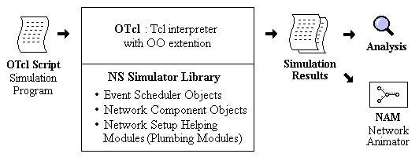

Simplified User's View of NS
NS is Object-oriented Tcl (OTcl) script interpreter that has a simulation event scheduler and network component object libraries, and network setup (plumbing) module libraries (actually, plumbing modules are implemented as member functions of the base simulator object). In other words, to use NS, you program in OTcl script language. To setup and run a simulation network, a user should write an OTcl script that initiates an event scheduler, sets up the network topology using the network objects and the plumbing functions in the library, and tells traffic sources when to start and stop transmitting packets through the event scheduler. The term "plumbing" is used for a network setup, because setting up a network is plumbing possible data paths among network objects by setting the "neighbor" pointer of an object to the address of an appropriate object. When a user wants to make a new network object, he or she can easily make an object either by writing a new object or by making a compound object from the object library, and plumb the data path through the object. This may sound like complicated job, but the plumbing OTcl modules actually make the job very easy. The power of NS comes from this plumbing.
Another major component of NS beside network objects is the event scheduler. An event in NS is a packet ID that is unique for a packet with scheduled time and the pointer to an object that handles the event. In NS, an event scheduler keeps track of simulation time and fires all the events in the event queue scheduled for the current time by invoking appropriate network components, which usually are the ones who issued the events, and let them do the appropriate action associated with packet pointed by the event. Network components communicate with one another passing packets, however this does not consume actual simulation time. All the network components that need to spend some simulation time handling a packet (i.e. need a delay) use the event scheduler by issuing an event for the packet and waiting for the event to be fired to itself before doing further action handling the packet. For example, a network switch component that simulates a switch with 20 microseconds of switching delay issues an event for a packet to be switched to the scheduler as an event 20 microsecond later. The scheduler after 20 microseconds dequeues the event and fires it to the switch component, which then passes the packet to an appropriate output link component. Another use of an event scheduler is timer.
NS is written not only in OTcl but in C++ also. For efficiency reason, NS separates the data path implementation from control path implementations. In order to reduce packet and event processing time (not simulation time), the event scheduler and the basic network component objects in the data path are written and compiled using C++. These compiled objects are made available to the OTcl interpreter through an OTcl linkage that creates a matching OTcl object for each of the C++ objects and makes the control functions and the configurable variables specified by the C++ object act as member functions and member variables of the corresponding OTcl object. In this way, the controls of the C++ objects are given to OTcl. It is also possible to add member functions and variables to a C++ linked OTcl object. The objects in C++ that do not need to be controlled in a simulation or internally used by another object do not need to be linked to OTcl. Likewise, an object (not in the data path) can be entirely implemented in OTcl. Figure 2 shows an object hierarchy example in C++ and OTcl. One thing to note in the figure is that for C++ objects that have an OTcl linkage forming a hierarchy, there is a matching OTcl object hierarchy very similar to that of C++.

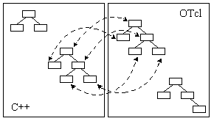

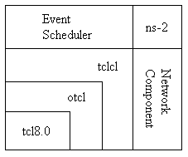
C++ and OTcl: The Duality

Architectural View of NS
The general architecture of NS. In this figure a general user (not an NS developer) can be thought of standing at the left bottom corner, designing and running simulations in Tcl using the simulator objects in the OTcl library. The event schedulers and most of the network components are implemented in C++ and available to OTcl through an OTcl linkage that is implemented using tcl. The whole thing together makes NS, which is a OO extended Tcl interpreter with network simulator libraries.
This section briefly examined the general structure and architecture of NS. At this point, one might be wondering about how to obtain NS simulation results.
When a simulation is finished, NS produces one or more text-based output files that contain detailed simulation data, if specified to do so in the input Tcl (or more specifically, OTcl) script. The data can be used for simulation analysis (two simulation result analysis examples are presented in later sections) or as an input to a graphical simulation display tool called Network Animator (NAM) that is developed as a part of VINT project. NAM has a nice graphical user interface similar to that of a CD player (play, fast forward, rewind, pause and so on), and also has a display speed controller. Furthermore, it can graphically present information such as throughput and number of packet drops at each link, although the graphical information cannot be used for accurate simulation analysis.
This section shows a simple NS simulation script and explains what each line does. OTcl script creates the simple network configuration and runs the simulation scenario.

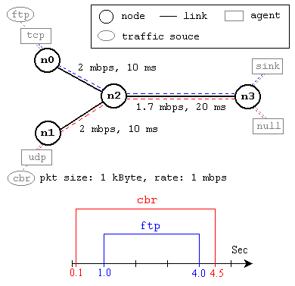
A Simple Network Topology and Simulation Scenario
This network consists of 4 nodes (n0, n1, n2, n3) as shown in above figure. The duplex links between n0 and n2, and n1 and n2 have 2 Mbps of bandwidth and 10 ms of delay. The duplex link between n2 and n3 has 1.7 Mbps of bandwidth and 20 ms of delay. Each node uses a DropTail queue, of which the maximum size is 10. A "tcp" agent is attached to n0, and a connection is established to a tcp "sink" agent attached to n3. As default, the maximum size of a packet that a "tcp" agent can generate is 1KByte. A tcp "sink" agent generates and sends ACK packets to the sender (tcp agent) and frees the received packets. A "udp" agent that is attached to n1 is connected to a "null" agent attached to n3. A "null" agent just frees the packets received.
The following is the explanation of the script above. In general, an NS script starts with making a Simulator object instance.
set ns [new Simulator]: generates an NS simulator object instance, and assigns it to variable ns (italics is used for variables and values in this section).
o Initialize the packet format (ignore this for now) o Create a scheduler (default is calendar scheduler)
o Select the default address format (ignore this for now)

The "Simulator" object has member functions that do the following: ✓Create compound objects such as nodes and links (described later) ✓Connect network component objects created (ex. attach-agent) ✓Set network component parameters (mostly for compound objects)
✓Create connections between agents (ex. make connection between a "tcp" and "sink")
✓Specify NAM display options

Most of member functions are for simulation setup and scheduling, however some of them are for the NAM display. The "Simulator" object member function implementations are located in the "ns-2/tcl/lib/ns-lib.tcl" file.
$ns color fid color: is to set color of the packets for a flow specified by the flow id (fid). This member function of "Simulator" object is for the NAM display, and has no effect on the actual simulation.
$ns namtrace-all file-descriptor: This member function tells the simulator to record simulation traces in NAM input format. It also gives the file name that the trace will be written to later by the command $ns flush-trace. Similarly, the member function trace-all is for recording the simulation trace in a general format.
proc finish : is called after this simulation is over by the command $ns at 5.0 "finish". In this function, post-simulation processes are specified.
set n0 [$ns node]: The member function node creates a node.
A node in NS is compound object made of address and port classifiers.
set tcp [new Agent/TCP]: This line shows how to create a TCP agent.
$ns at time "string": This member function of a Simulator object makes the scheduler (scheduler_ is the variable that points the scheduler object created by [new Scheduler] command at the beginning of the script) to schedule the execution of the specified string at given simulation time. After all network configuration, scheduling and post-simulation procedure specifications are done, the only thing left is to run the simulation. This is done by $ns run.

NODE AND ROUTING
A node is a compound object composed of a node entry object and classifiers as shown in Figure 7. There are two types of nodes in NS. A unicast node has an address classifier that does unicast routing and a port classifier. A multicast node, in addition, has a classifier that classify multicast packets from unicast packets and a multicast classifier that performs multicast routing.

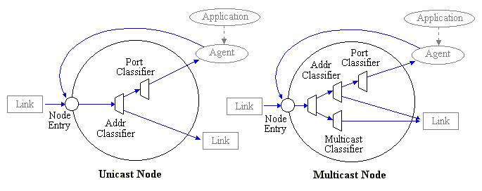
Node (Unicast and Multicast)

In NS, Unicast nodes are the default nodes. To create Multicast nodes the user must explicitly notify in the input OTcl script, right after creating a scheduler object, that all the nodes that will be created are multicast nodes. After specifying the node type, the user can also select a specific routing protocol other than using a default one.

Unicast

- $ns rtproto type
- type: Static, Session, DV, cost, multi-path
Multicast
- $ns multicast (right after set $ns [new Scheduler]) - $ns mrtproto type
- type: CtrMcast, DM, ST, BST

LINK

A link is another major compound object in NS. When a user creates a link using a duplex-link member function of a Simulator object, two simplex links in both directions are created.
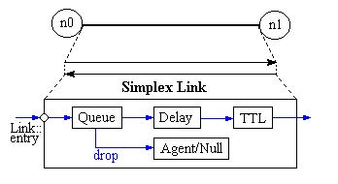

A Link

One thing to note is that an output queue of a node is actually implemented as a part of simplex link object. Packets dequeued from a queue are passed to the Delay object that simulates the link delay, and packets dropped at a queue are sent to a Null Agent and are freed there. Finally, the TTL object calculates Time To Live parameters for each packet received and updates the TTL field of the packet.
Tracing

In NS, network activities are traced around simplex links. If the simulator is directed to trace network activities (specified using $ns trace-all file or $ns namtrace-all file), the links created after the command will have the following trace objects inserted as shown in Figure 9. Users can also specifically create a trace object of type type between the given src and dst nodes using the create-trace type file src dst command.
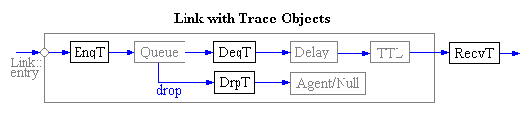

Inserting Trace Objects

When each inserted trace object (i.e. EnqT, DeqT, DrpT and RecvT) receives a packet, it writes to the specified trace file without consuming any simulation time, and passes the packet to the next network object.

Queue Monitor

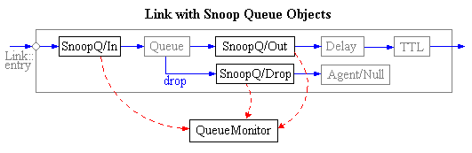
Basically, tracing objects are designed to record packet arrival time at which they are located. Although a user gets enough information from the trace, he or she might be interested in what is going on inside a specific output queue. For example, a user interested in RED queue behavior may want to measure the dynamics of average queue size and current queue size of a specific RED queue (i.e. need for queue monitoring). Queue monitoring can be achieved using queue monitor objects and snoop queue objects.

Monitoring Queue

When a packet arrives, a snoop queue object notifies the queue monitor object of this event. The queue monitor using this information monitors the queue. A RED queue monitoring example is shown in the RED Queue Monitor Example section. Note that snoop queue objects can be used in parallel with tracing objects even though it is not shown in the above figure.

PACKET FLOW EXAMPLE
Until now, the two most important network components (node and link) were examined. This Figure shows is example simulation network setup and packet flow. The network consist of two nodes (n0 and n1) of which the network addresses are 0 and 1 respectively. A TCP agent attached to n0 using port 0 communicates with a TCP sink object attached to n1 port 0. Finally, an FTP application (or traffic source) is attached to the TCP agent, asking to send some amount of data.

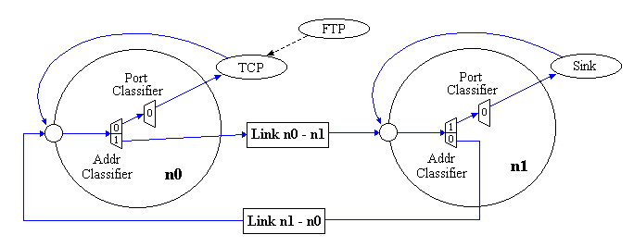
Packet Flow Example

Note that the above figure does not show the exact behavior of a FTP over TCP. It only shows the detailed internals of simulation network setup and a packet flow.

PACKET:
A NS packet is composed of a stack of headers, and an optional data space. The header format is initialized when a Simulator object is created, where a stack of all registered (or possibly useable) headers, such as the common header that is commonly used by any objects as needed, IP header, TCP header, RTP header (UDP uses RTP header) and trace header, is defined, and the offset of each header in the stack is recorded. What this means is that whether or not a specific header is used, a stack composed of all registered headers is created when a packet is allocated by an agent, and a network object can access any header in the stack of a packet it processes using the corresponding offset value.

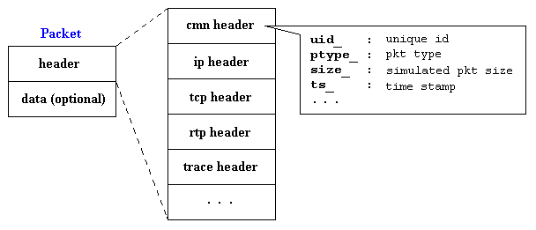
NS Packet Format

Usually, a packet only has the header stack (and a data space pointer that is null). Although a packet can carry actual data (from an application) by allocating a data space, very few application and agent implementations support this. This is because it is meaningless to carry data around in a non-real-time simulation. However, if you want to implement an application that talks to another application cross the network, you might want to use this feature with a little modification in the underlying agent implementation. Another possible approach would be creating a new header for the application and modifying the underlying agent to write data received from the application to the new header. The second approach is shown as an example in a later section called "Add New Application and Agent".

RESULT
The NS2 (Network Simulator 2) has been studied.

15. PERFORMANCE STUDY OF TRANSMISSION CONTROL PROTOCOL

AIM
To study the performance of Transmission Control Protocol using NS2 simulator.

OBJECTIVE
To learn about the performance of TCP using NS2 simulator.

SOFTWARE REQUIRED
NS2 Simulator

DESCRIPTION
Transmission Control Protocol (TCP) Is one of the core protocols of the IP and is often called TCP/IP. TCP provides reliable, ordered, error checked delivery of stream octets. TCP can be implemented using NS2. NS2 is often criticized because modeling is a very complex and time consuming task since it has nu GUI and one needs to learn scripting language. Using NS2 modeling and simulation services are provided in a variety of networking technologies and protocols.

ALGORITHM
1) Open cygwin.exe.
2) Navigate the folder named ns-allinone-2.31 in the system.
3) Start Xwin by typing StartxWIN.bat.
4) On typing ns on the new windows command prompt, ‘$’ gets changed to ‘%’.
5) Use vi editor to write the program and save it in .tcl format.
6) In the program, set the nodes and establish the link between required nodes.
7) Set the source and destination nodes with TCP and exit the prompt with %
8) Execute the program by typing “ns filename.tcl”.
9) A new window called Network Animator opens up and a trace file is created.
10) Using the values in trace file, efficiency and throughput is calculated.

PROGRAM
set ns [new Simulator]
set nf [open TCP33.nam w]
$ns namtrace-all $nf
set tf [open TCP33.tr w]
$ns trace-all $tf
proc finish {} {
global ns nf tf
$ns flush-trace
close $nf
close $tf
exec nam TCP33.nam &
exit 0
}
set n0 [$ns node]
set n1 [$ns node]
set n2 [$ns node]
set n3 [$ns node]
set n4 [$ns node]
set n5 [$ns node]
set n6 [$ns node]
$ns duplex-link $n0 $n4 1Kb 50ms DropTail
$ns duplex-link $n1 $n4 1Mb 50ms DropTail
$ns duplex-link $n2 $n5 1Kb 50ms DropTail
$ns duplex-link $n3 $n5 1Mb 50ms DropTail
$ns duplex-link $n4 $n5 100Kb 50ms DropTail
$ns duplex-link $n6 $n5 1Mb 50ms DropTail
set source1 [new Agent/TCP]
$ns attach-agent $n0 $source1
set dest [new Agent/TCP]
$ns attach-agent $n2 $dest
$ns connect $source1 $dest
set appl [new Application/FTP]
$appl attach-agent $source1
$ns at 0.0 "$appl start"
$ns at 3.9 "$appl stop"
$ns at 4.0 "finish"
$ns run

OUTPUT
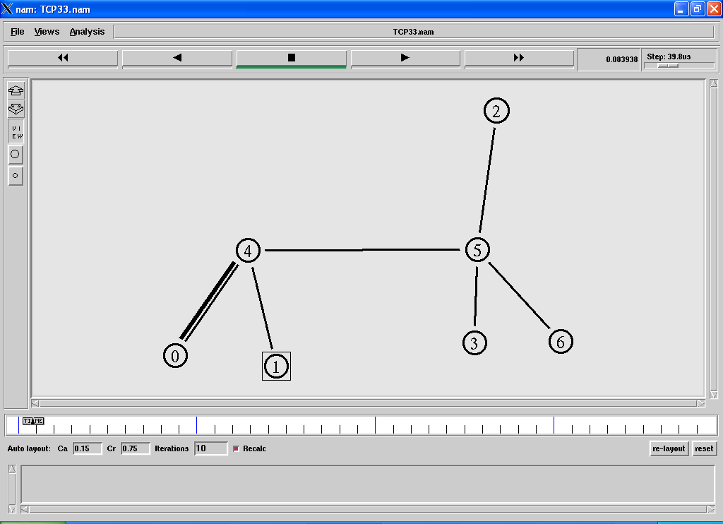

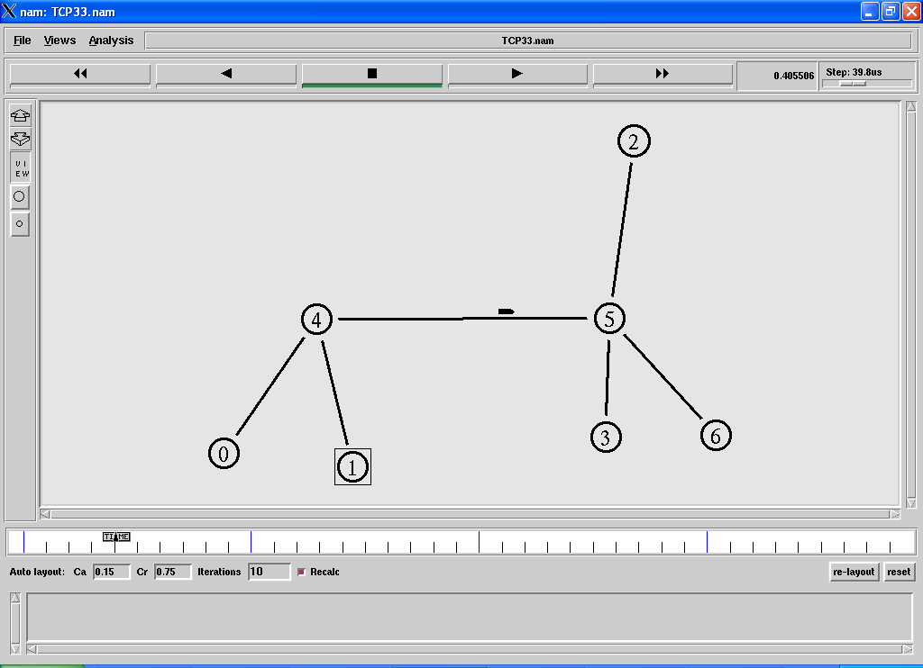

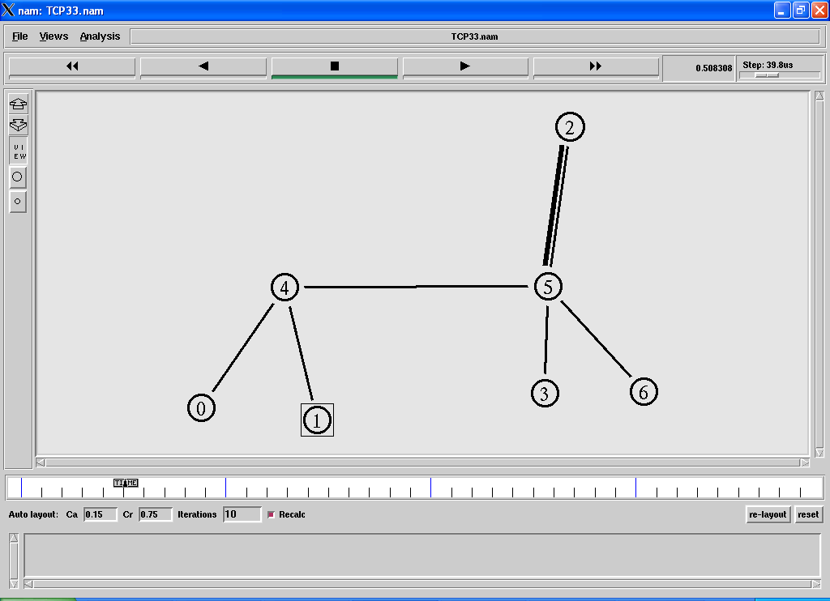

TRACE FILE
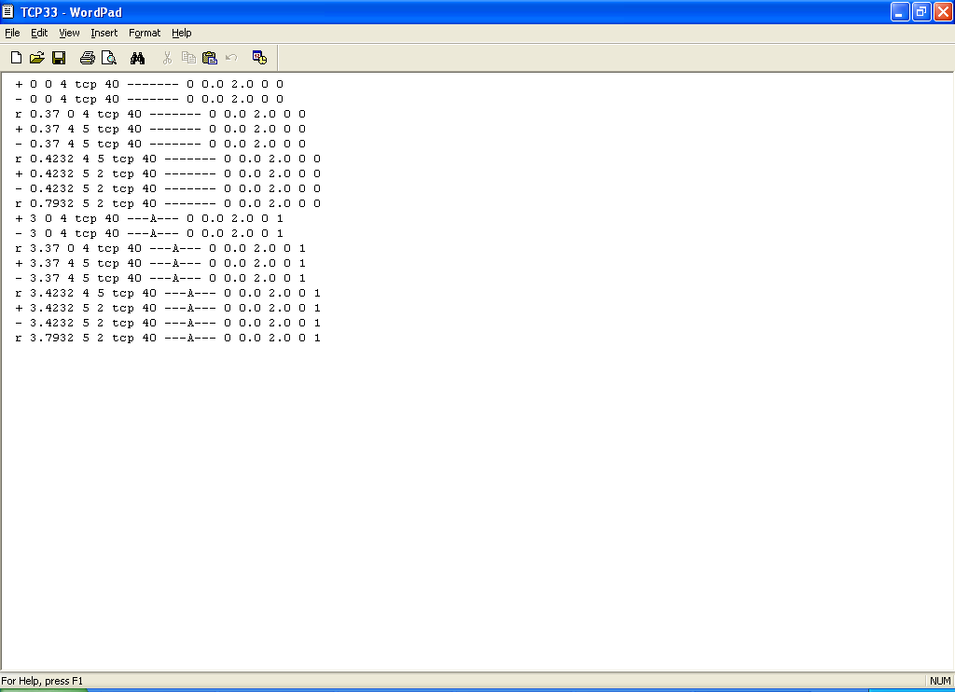

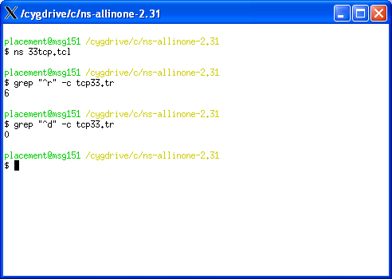

Calculation

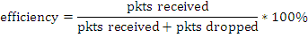
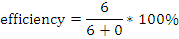

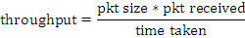

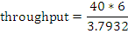

RESULT
The performance of TCP is studied and its efficiency and throughput are computed using NS2 simulator.

16. PERFORMANCE STUDY OF CONGESTION CONTROL ALGORITHM

AIM
To study the performance of Transmission Control Protocol using NS2 simulator.

OBJECTIVE
To learn about the performance of TCP using NS2 simulator.

SOFTWARE REQUIRED
NS2 Simulator

DESCRIPTION
Transmission Control Protocol (TCP) Is one of the core protocols of the IP and is often called TCP/IP. TCP provides reliable, ordered, error checked delivery of stream octets. TCP can be implemented using NS2. NS2 is often criticized because modeling is a very complex and time consuming task since it has nu GUI and one needs to learn scripting language. Using NS2 modeling and simulation services are provided in a variety of networking technologies and protocols.

ALGORITHM
1) Open cygwin.exe.
2) Navigate the folder named ns-allinone-2.31 in the system.
3) Start Xwin by typing StartxWIN.bat.
4) On typing ns on the new windows command prompt, ‘$’ gets changed to ‘%’.
5) Use vi editor to write the program and save it in .tcl format.
6) In the program, set the nodes and establish the link between required nodes.
7) Set the source and destination nodes with TCP and exit the prompt with %
8) Execute the program by typing “ns filename.tcl”.
9) A new window called Network Animator opens up and a trace file is created.
10) Using the values in trace file, efficiency and throughput is calculated

PROGRAM:
set ns [new Simulator]
set nf [open congout.nam w]
set tf [open congout.tr w]
$ns trace-all $tf
$ns namtrace-all $nf
proc finish {} {
global ns nf
$ns flush-trace
close $nf
exec nam congout.nam &
exit 0 }
set n0 [$ns node]
set n1 [$ns node]
set n2 [$ns node]
set n3 [$ns node]
set n4 [$ns node]
set n5 [$ns node]
#create links between the nodes
$ns duplex-link $n0 $n2 2Mb 10ms DropTail
$ns duplex-link $n1 $n2 2Mb 10ms DropTail
$ns simplex-link $n2 $n3 0.3Mb 100ms DropTail
$ns simplex-link $n3 $n2 0.3Mb 100ms DropTail
$ns duplex-link $n3 $n4 0.5Mb 40ms DropTail
$ns duplex-link $n3 $n5 0.5Mb 30ms DropTail
#Set Queue Size of link (n2-n3) to 10
$ns queue-limit $n2 $n3 20
#Setup a TCP connection
set tcp [new Agent/TCP/Newreno]
$ns attach-agent $n0 $tcp
set sink [new Agent/TCPSink/DelAck]
$ns attach-agent $n4 $sink
$ns connect $tcp $sink
$tcp set fid_ 1
$tcp set window_ 8000
$tcp set packetSize_ 552
#Setup a FTP over TCP connection
set ftp [new Application/FTP]
$ftp attach-agent $tcp
$ftp set type_ FTP
#Setup a UDP connection
set udp [new Agent/UDP]
$ns attach-agent $n1 $udp
set null [new Agent/Null]
$ns attach-agent $n5 $null
$ns connect $udp $null
$udp set fid_ 2
#Setup a CBR over UDP connection
set cbr [new Application/Traffic/CBR]
$cbr attach-agent $udp
$cbr set type_ CBR
$cbr set packet_size_ 1000
$cbr set rate_ 0.01mb
$cbr set random_ false
$ns at 0.1 "$cbr start"
$ns at 1.0 "$ftp start"
$ns at 10.0 "$ftp stop"
$ns at 10.5 "$cbr stop"
$ns at 11.0 "finish"
$ns run

OUTPUT:

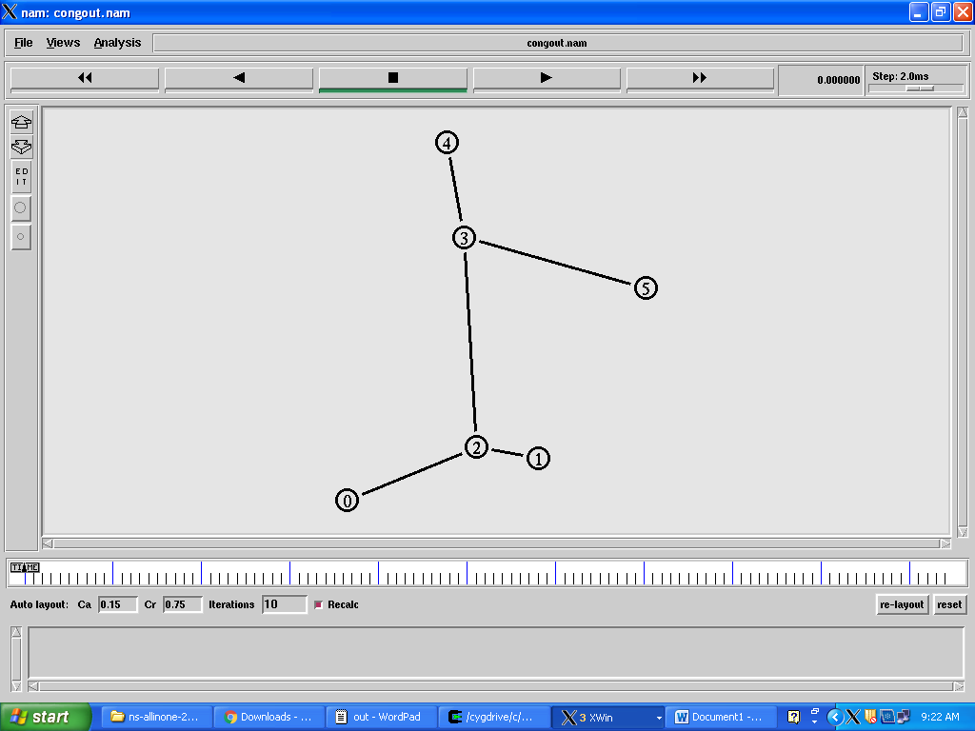
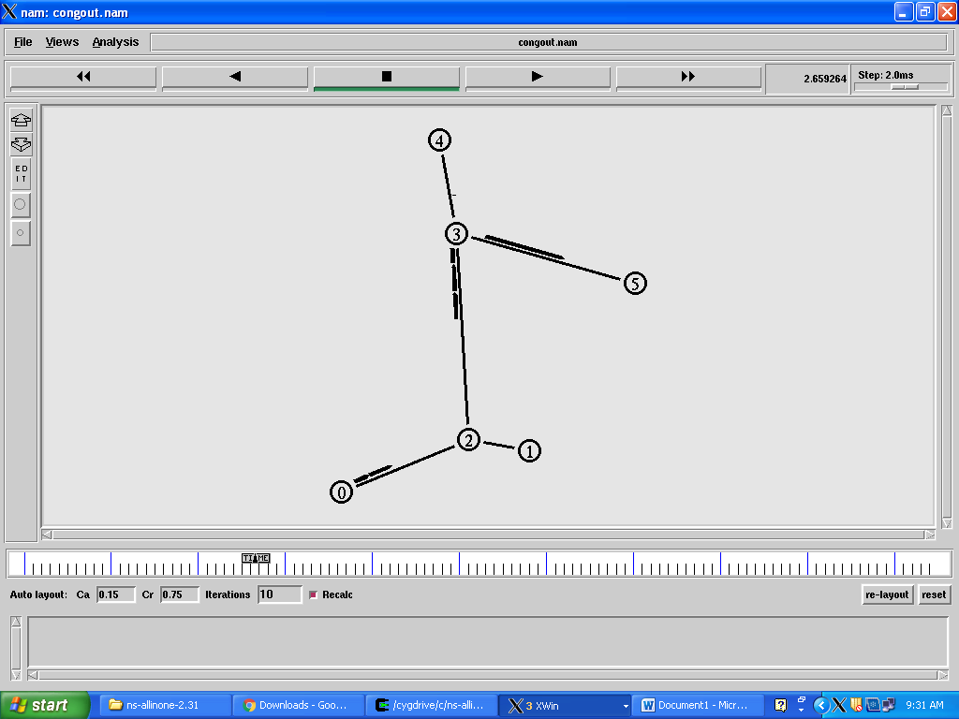

RESULT
The congestion control algorithm has been computed using NS2 simulator.

17.PERFORMANCE STUDY OF LINKSTATE,DISTANCE VECTOR AND FLOODING ROUTING ALGORITHMS
AIM:
To study the performance of link state,distance vector and flooding algorithms.

OBJECTIVE:
To understand the algorithms link state ,distance vector and flooding.

SOFTWARE REQUIRED:
Network Simulator Version 2.

DESCRIPTION
Link State routing
Routing is the process of selecting best paths in a network. Routing is performed for many kinds of networks, including the telephone network (circuit switching), electronic data networks (such as the Internet), and transportation networks. In packet switching networks, routing directs packet forwarding (the transit of logically addressed network packets from their source toward their ultimate destination) through intermediate nodes. Intermediate nodes are typically network hardware devices such as routers, bridges, gateways, firewalls, or switches. General-purpose computers can also forward packets and perform routing, though they are not specialized hardware and may suffer from limited performance. The routing process usually directs forwarding on the basis of routing tables which maintain a record of the routes to various network destinations. Thus, constructing routing tables, which are held in the router's memory, is very important for efficient routing. Most routing algorithms use only one network path at a time. Multipath routing techniques enable the use of multiple alternative paths.
In case of overlapping/equal routes, the following elements are considered in order to decide which routes get installed into the routing table (sorted by priority):
1. Prefix-Length: where longer subnet masks are preferred (independent of whether it is within a routing protocol or over different routing protocol)
2. Metric: where a lower metric/cost is preferred (only valid within one and the same routing protocol)
3. Administrative distance: where a lower distance is preferred (only valid between different routing protocols)
. Distance vector
In computer communication theory relating to packet-switched networks, a distance-vector routing protocol is one of the two major classes of routing protocols, the other major class being the link-state protocol. Distance-vector routing protocols use the Bellman–Ford algorithm, Ford–Fulkerson algorithm to calculate paths.
A distance-vector routing protocol requires that a router informs its neighbors of topology changes periodically. Compared to link-state protocols, which require a router to inform all the nodes in a network of topology changes, distance-vector routing protocols have less computational complexity and message overhead.
The term distance vector refers to the fact that the protocol manipulates vectors (arrays) of distances to other nodes in the network. The vector distance algorithm was the original ARPANET routing algorithm and was also used in the internet under the name of RIP (Routing Information Protocol).
Examples of distance-vector routing protocols include RIPv1 and RIPv2 and IGRP.
Method
Routers using distance-vector protocol do not have knowledge of the entire path to a destination. Instead they use two methods:
1. Direction in which router or exit interface a packet should be forwarded.
2. Distance from its destination

Distance-vector protocols are based on calculating the direction and distance to any link in a network. "Direction" usually means the next hop address and the exit interface. "Distance" is a measure of the cost to reach a certain node. The least cost route between any two nodes is the route with minimum distance. Each node maintains a vector (table) of minimum distance to every node. The cost of reaching a destination is calculated using various route metrics. RIP uses the hop count of the destination whereas IGRP takes into account other information such as node delay and available bandwidth.
Updates are performed periodically in a distance-vector protocol where all or part of a router's routing table is sent to all its neighbors that are configured to use the same distance-vector routing protocol. RIP supports cross-platform distance vector routing whereas IGRP is a Cisco Systems proprietary distance vector routing protocol. Once a router has this information it is able to amend its own routing table to reflect the changes and then inform its neighbors of the changes. This process has been described as ‗routing by rumor‘ because routers are relying on the information they receive from other routers and cannot determine if the information is actually valid and true. There are a number of features which can be used to help with instability and inaccurate routing information.
EGP and BGP are not pure distance-vector routing protocols because a distance-vector protocol calculates routes based only on link costs whereas in BGP, for example, the local route preference value takes priority over the link cost.
Count-to-infinity problem
The Bellman–Ford algorithm does not prevent routing loops from happening and suffers from the count-to-infinity problem. The core of the count-to-infinity problem is that if A tells B that it has a path somewhere, there is no way for B to know if the path has B as a part of it. To see the problem clearly, imagine a subnet connected like A–B–C–D–E–F, and let the metric between the routers be "number of jumps". Now suppose that A is taken offline. In the vector-update-process B notices that the route to A, which was distance 1, is down – B does not receive the vector update from A. The problem is, B also gets an update from C, and C is still not aware of the fact that A is down – so it tells B that A is only two jumps from C (C to B to A), which is false. This slowly propagates through the network until it reaches infinity (in which case the algorithm corrects itself, due to the relaxation property of Bellman–Ford).
Flooding
Flooding s a simple routing algorithm in which every incoming packet is sent through every outgoing link except the one it arrived on.Flooding is used in bridging and in systems such as Usenet and peer-to-peer file sharing and as part of some routing protocols, including OSPF, DVMRP, and those used in ad-hoc wireless networks.There are generally two types of flooding available, Uncontrolled Flooding and Controlled Flooding.Uncontrolled Flooding is the fatal law of flooding. All nodes have neighbours and route packets indefinitely. More than two neighbourscreates a broadcast storm.
Controlled Flooding has its own two algorithms to make it reliable, SNCF (Sequence Number Controlled Flooding) and RPF (Reverse Path Flooding). In SNCF, the node attaches its own address and sequence number to the packet, since every node has a memory of addresses and sequence numbers. If it receives a packet in memory, it drops it immediately while in RPF, the node will only send the packet forward. If it is received from the next node, it sends it back to the sender.
Algorithm
There are several variants of flooding algorithm.
1. Each node acts as both a transmitter and a receiver.
2. Each node tries to forward every message to every one of its neighbours except the source node.
This results in every message eventually being delivered to all reachable parts of the network. Algorithms may need to be more complex than this, since, in some case, precautions have to be taken to avoid wasted duplicate deliveries and infinite loops, and to allow messages to eventually expire from the system. A variant of flooding called selective flooding partially addresses these issues by only sending packets to routers in the same direction. In selective flooding the routers don't send every incoming packet on every line but only on those lines which are going approximately in the right direction.
➢ Flooding can be costly in terms of wasted bandwidth. While a message may only have one destination it has to be sent to every host. In the case of a ping flood or a denial of service attack, it can be harmful to the reliability of a computer network.
➢ Messages can become duplicated in the network further increasing the load on the networks bandwidth as well as requiring an increase in processing complexity to disregard duplicate messages.
➢ Duplicate packets may circulate forever, unless certain precautions are taken:
➢ Use a hop count or a time to live count and include it with each packet. This value should take into account the number of nodes that a packet may have to pass through on the way to its destination.
➢ Have each node keep track of every packet seen and only forward each packet once
➢ Enforce a network topology without loops

PROGRAM
LINK STATE
set ns [new Simulator]
setnf [open out.nam w]
$ns namtrace-all $nf
settr [open out.tr w]
$ns trace-all $tr
proc finish {} {
globalnf ns tr
$ns flush-trace
close $tr
execnamout.nam&
execxgraph out.tr -geometry 800*400 &
exit 0 }
set n0 [$ns node]
set n1 [$ns node]
set n2 [$ns node]
set n3 [$ns node]
$ns duplex-link $n0 $n1 10Mb 10ms DropTail
$ns duplex-link $n1 $n3 10Mb 10ms DropTail
$ns duplex-link $n2 $n1 10Mb 10ms DropTail
$ns duplex-link-op $n0 $n1 orient right-down
$ns duplex-link-op $n1 $n3 orient right
$ns duplex-link-op $n2 $n1 orient right-up
settcp [new Agent/TCP]
$ns attach-agent $n0 $tcp
set ftp [new Application/FTP]
$ftp attach-agent $tcp
set sink [new Agent/TCPSink]
$ns attach-agent $n3 $sink
setudp [new Agent/UDP]
$ns attach-agent $n2 $udp
setcbr [new Application/Traffic/CBR]
$cbr attach-agent $udp
set null [new Agent/Null]
$ns attach-agent $n3 $null
$ns connect $tcp $sink
$ns connect $udp $null
$ns rtmodel-at 1.0 down $n1 $n3
$ns rtmodel-at 2.0 up $n1 $n3
$ns rtproto LS
$ns at 0.0 "$ftp start"
$ns at 0.0 "$cbr start"
$ns at 5.0 "finish"
$ns run
FLOOD
# create simulator instance
set ns [new Simulator]
# setup topography object
settopo [new Topography]
#use new trace format
$ns_ use-newtrace
# create trace object for ns and nam
settracefd [open flood.tr w]
$ns_ trace-all $tracefd
setnamtrace [open flood.nam w]
$ns_ namtrace-all-wireless $namtrace $val(x) $val(y)
# define topology
$topoload_flatgrid $val(x) $val(y)
set god_ [create-god $val(nn)]
set chan_1_ [new $val(chan)]
#global node setting
$ns_ node-config -adhocRouting $val(adhocRouting) \
-llType $val(ll) \
-macType $val(mac) \
-ifqType $val(ifq) \
-ifqLen $val(ifqlen) \
-antType $val(ant) \
-propType $val(prop) \
-phyType $val(netif) \
-topoInstance $topo \
-agentTrace ON \
-routerTrace ON \
-macTrace OFF \
-mobilityTrace OFF \
-channel $chan_1_
for {set i 0} {$i < $val(nn) } {incr i} {
set node_($i) [$ns_ node $i]
$node_($i) random-motion 0 ;# disable random motion }
$god_ set-dist 0 1 1
#setting initial positions of the nodes
#nodes are stationary for throughout the simulation
$node_(0) set Z_ 0.000000000000
$node_(0) set Y_ 0.00
$node_(0) set X_ 0.00
$node_(1) set Z_ 0.000000000000
$node_(1) set Y_ 0.0
$node_(1) set X_ 10.0
#creating a CBR flow from node 0 to node 1
setudp_(0) [new Agent/UDP]
$ns_ attach-agent $node_(0) $udp_(0)
set null_(0) [new Agent/Null]
$ns_ attach-agent $node_(1) $null_(0)
setcbr_(0) [new Application/Traffic/CBR]
$cbr_(0) set packetSize_ 512
$cbr_(0) set interval_ .0025
$cbr_(0) set random_ false
$cbr_(0) set maxpkts_ 10000
$cbr_(0) set maxpkts_ 1
$cbr_(0) attach-agent $udp_(0)
$ns_ connect $udp_(0) $null_(0)
$ns_ at 5.00 "$cbr_(0) start"
# Tell nodes when the simulation ends
for {set i 0} {$i < $val(nn) } {incr i} {
$ns_ at $val(stop).0 "$node_($i) reset";}
$ns_ at $val(stop).0002 "puts \"NS EXITING...\" ; $ns_ halt"
puts "Starting Simulation..."
$ns run
DISTANCE VECTOR
set ns [new Simulator]
setnf [open out.nam w]
$ns namtrace-all $nf
settr [open out.tr w]
$ns trace-all $tr
proc finish {} {
globalnf ns tr
$ns flush-trace
close $tr
execnamout.nam&
execxgraph out.tr -geometry 800*400 &
exit 0 }
set n0 [$ns node]
set n1 [$ns node]
set n2 [$ns node]
set n3 [$ns node]
$ns duplex-link $n0 $n1 10Mb 10ms DropTail
$ns duplex-link $n1 $n3 10Mb 10ms DropTail
$ns duplex-link $n2 $n1 10Mb 10ms DropTail
$ns duplex-link-op $n0 $n1 orient right-down
$ns duplex-link-op $n1 $n3 orient right
$ns duplex-link-op $n2 $n1 orient right-up
settcp [new Agent/TCP]
$ns attach-agent $n0 $tcp
set ftp [new Application/FTP]
$ftp attach-agent $tcp
set sink [new Agent/TCPSink]
$ns attach-agent $n3 $sink
setudp [new Agent/UDP]
$ns attach-agent $n2 $udp
setcbr [new Application/Traffic/CBR]
$cbr attach-agent $udp
set null [new Agent/Null]
$ns attach-agent $n3 $null
$ns connect $tcp $sink
$ns connect $udp $null
$ns rtmodel-at 1.0 down $n1 $n3
$ns rtmodel-at 2.0 up $n1 $n3
$ns rtproto DV
$ns at 0.0 "$ftp start"
$ns at 0.0 "$cbr start"
$ns at 5.0 "finish"
$ns run

RESULT:
The performance of Link State,Distance Vector and Flooding Algorithms are studied.

